week10

08/04

Gavin messaged me, and gave me an option to include another person, and I said yes because the more help the better. I wanted someone to help me with the errors, I was facing and to add the music into the game,and someone to help with the animations, if we need any. We decided to meet in the gavin lab on Thursday, since she was struggling with installing her unity, and getting the actual github repo into her unity.I helped a team member install unity and GitHub. I explained what they both do.I  explain what the game was about and what each code file within the actual repo does. I explained what my problem was now and what I needed to do to fix it in detail. Gavin told me that I should start writing my problem down to help my teammate understand, since when I tried to explain to him what I wanted, he couldn't understand what I wanted to be fixed. So, I went from the start to finish on what happened in each scene, how the mechanism worked in written format.

Idk what I did but my problem is when I click the cherry the cipher would say it's clicked. Only problem I have now is making sure that before all the cherries are clicked the gems will say locked and when they are clicked, and progress bar is full then the gem will say unlocked. Clicking on gems only triggers the degum no item hit.

We decided to look over the code and try to figure out the problems, she noticed that I had multiple code that did the same thing, and suggested that I remove the duplicates, there’s a high chance it caused the problem.

Ok now when I click gem first it does say it's locked, but it also says it's unlocked straight after, which isn't what I wanted.

I tried forcing a while loop around the cherries, it crashed um

What I know

It works but its not working after the progressbar is full for some reason.its doing it before

It does say the Painting is unlocked when I click on Cipher1 which is what I wanted, so I know the painting unlocking after the gem does work.

 started organizing my code, since I realized that I had the same debug in 2 methods. I wanted the Painting1 to be unlocked automatically, so I made it like that.

I removed all the raycast and stuck within using OnMouseDown for clicks which fixed the cipher being unlocked occurring when I clicked on cherry.Only problem I have now is that it's saying no item hit when i click on cipher.

What I want to do:

I want when i press on the gem, I want it to say its locked ,and when i clicked all the cherries and it says progressbar is full, i want it to say its unlocked first then send u to the gallery scene

I figured out that I was restarting my progress to 0 every time it was full,which was the reason why it wasn't saying it was unlocked.I fixed it by specifying that i want it to check if its unlocked or not in the same code as the clickitem under when item clicked is cipher1 and calling the unlockManager method within it.Only problem I have now is that when I click on the cipher1 before the cherries it says its unlocked not locked,but it does say that it is is locked before i click on it.I had duplicates of unlocking in multiple methods, so i i had a specific method just for the unlocking.

Next when I click on Painting1 nothing happens, i'm giving it the same code as the cipher1.

When I tried to call the method that handles what happens once an item is unlocked(HandleUnlockables),It says null.I just directly put the changing of scenes if a painting was clicked, and the cipher is added to inventory once the cipher is clicked(when progressbar is full).

I tried to call my Handle Unlockables script but I was always getting an error that it was null,so I decided to ignore that method and directly change scenes if painting is clicked,and directly add the cipher to inventory when the cipher is clicked.

10/04

I put the music files in the right folder,within Github so that the person that is putting the music within the game, is able to know where to find it.I just went to its file in github and changed its file path.I told the new teammate that I want her to focus on figuring out how to add sound files (which my other Muireann created) to the scenes.We decided to meet up in real life at least two days.I may or may not be able to do that,since I will be going back home for the holidays.

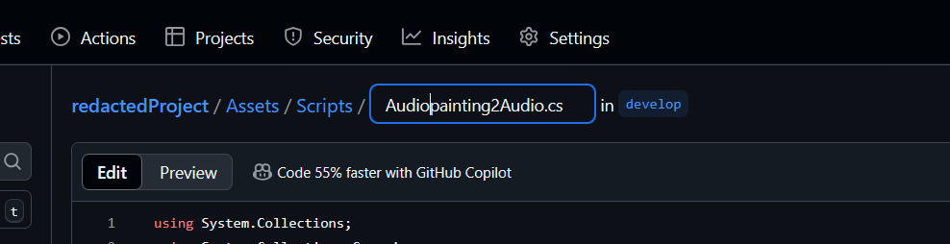

During the team meeting at 3pm, I told my teammates that they would need to install github Desktop in order to pull the changes from github into their local repository.I helped kiki set this up,since we are going to be working together the most,since she is doing the UI and Im putting everyone else's code together, which is basically teh gameplay without the ui and taskstaks completeed.I showed my teammates what I have done and explained what I will ended to do next.

Before adding the gem to inventory i need to

When i click on the gem it says locked

When i click all the cherries and its says progresbar is full

Then i wnat it to say cipher 1 is locked

13/04

 I decided to add boolean values .so it will properly track when painting is clicked and its unlocked then go to next scene.it prevents any errors from happening.I made all the game objects that i will need in a scene as prefabs so i don't have to repeatedly refer scripts.

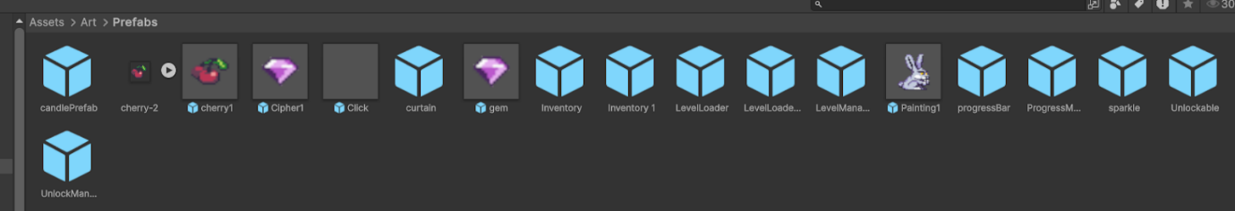

I will replace the rabbit and gem with the right image .

I am met with problems

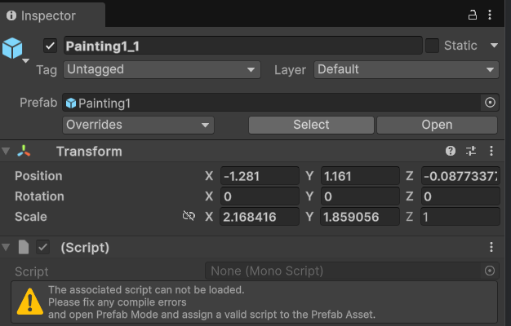

That happened because I merged the dialogue changes, which said

When c1 and c2 is clicked and unlocked then p2_1 is unlocked

Instead of having if else statements ,as shown for Painting1,I decided to use the if else etc within Check ProgressAnd Unlock,so I can reuse it for multiple ites.IT does work when I run it.I did some research and I realized that I needed to add the click script to every object I want to click,since I use OnMouseDown not raycasting.That must be the reason why the objects were not registering my clicks.I learned the difference between private ,public and serialised fields.I have to make game objects to refer to the class in the inspector.Unitybis component based so in order to refer to inventory i will need to refer to the inventory in the inspector.

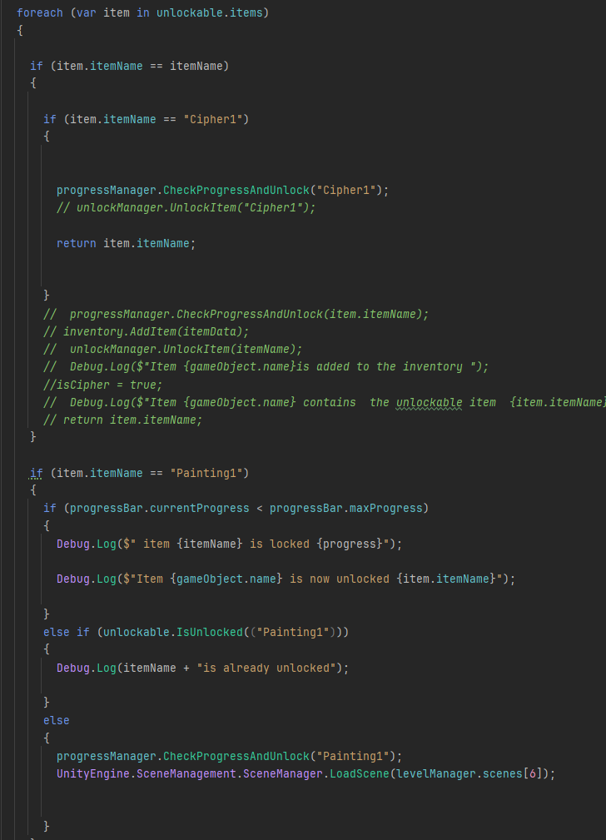

Faced another problem

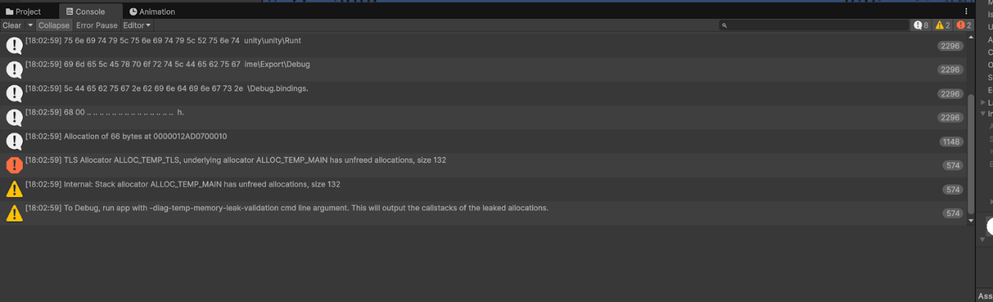

Faced another problem. It does not register if painting is clicked, I fixed it by removing return null.I realised that its returning null before it checks if painting is clicked.

I fixed the problem of the painting1 not unlcoking.It was because in my Hand Unlockables I was calling OnItemClick within it,and i was calling HandleUnlockables within OnItemClick,so it was calling both which caused a stack overflow.

I fixed it by removing it.

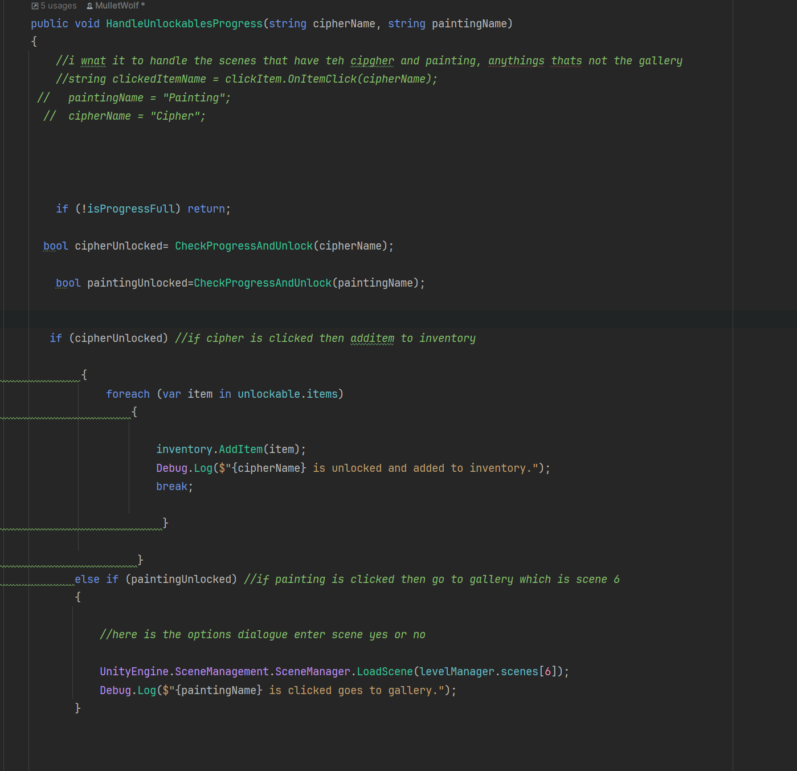

Week11

14/04

The clicking items and the cipher and painting unlocks works.When painting is unlocked and clicked ,brings you to gallery which works.Now I am trying to make teh when you click on painting in gallery and ist unlocked it brings you to the next scene.The rabbits are painting to painting 3.Not final product just fake .

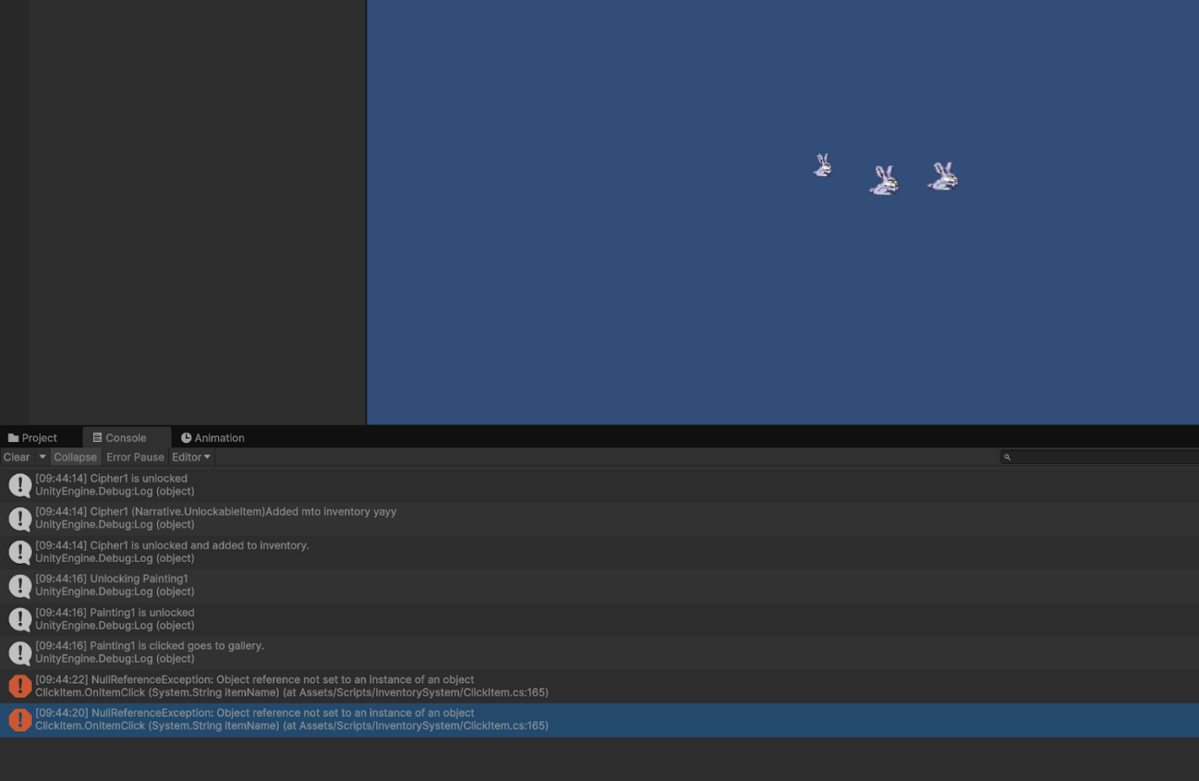

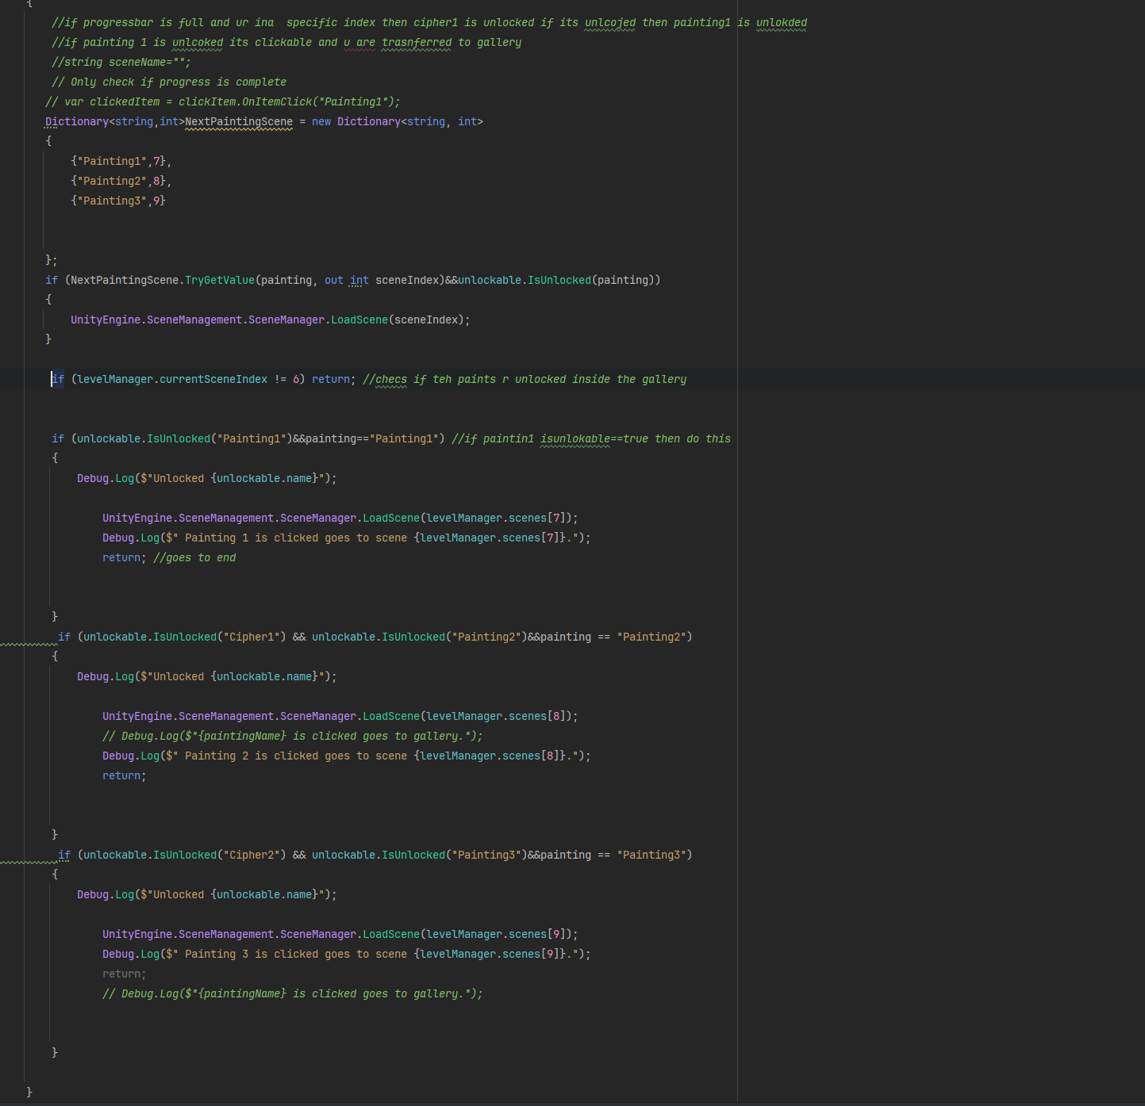

The Deictonair use at this time,

Other problem.When I am In the gallery with the 3 paintings,it doesn't bring me to the scene.I realized that it could be because I have the same painting name for the ones inside the painting and the ones in the gallery.So I should increase the itemDictionary to have 3 more paintings

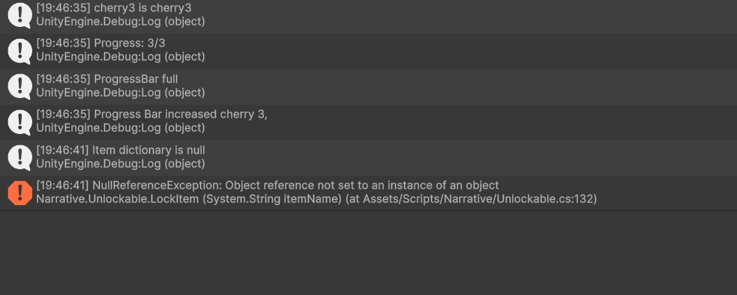

It says the dictionary which i hold my unlockable items where their key is the name,

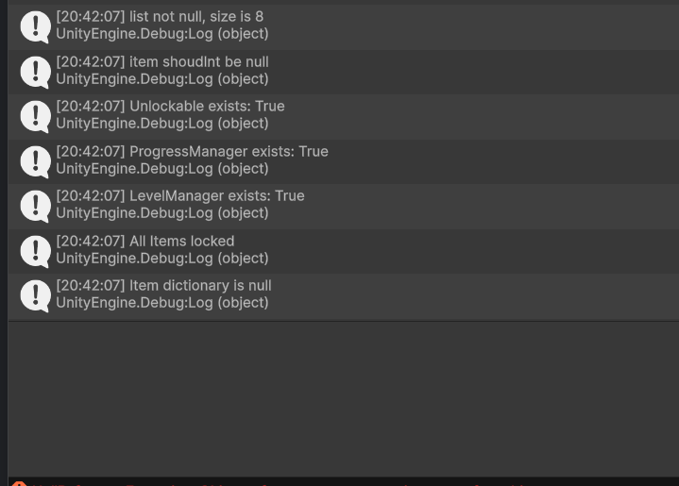

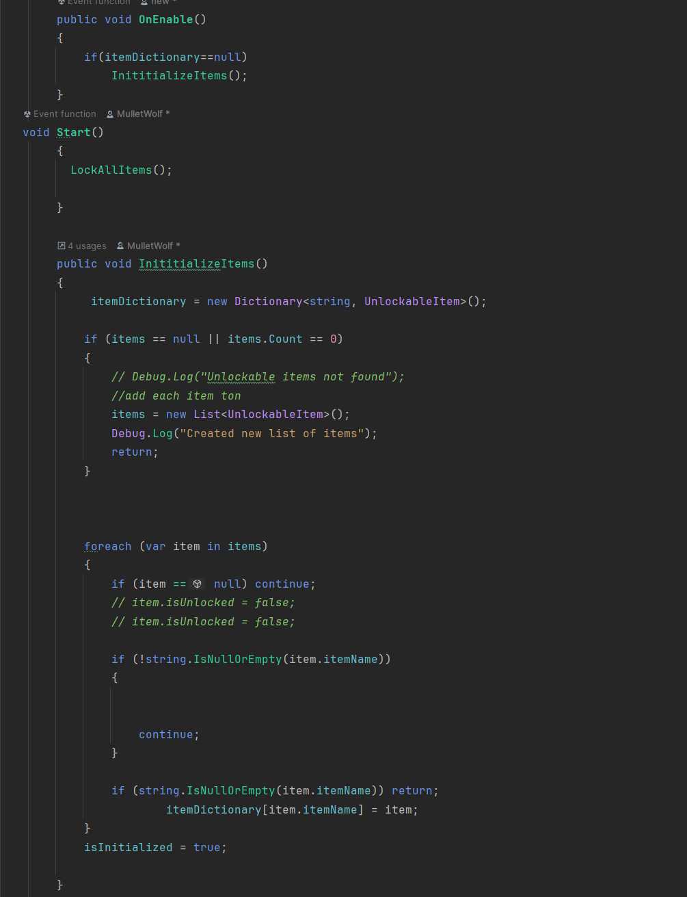

I realized the reason why my painting was not clickable is because I didn't have the click script and the box collider on it.The list that contains the unlockable items is null,but the dictionary is null, which make no sense since i used a for loop where each item of items is put into itemDictionary, yet it says its null.

After a lot of trial and error of putting debugs in  everything I realized thatI should just remove itemDictionary since the only use I have for it is for fast lookup.And I can just use the list of unlockableItems to access each item.

After I got rid of the itemDictionary it was weird.I just removed everything related to it and changed it to refer to the list.

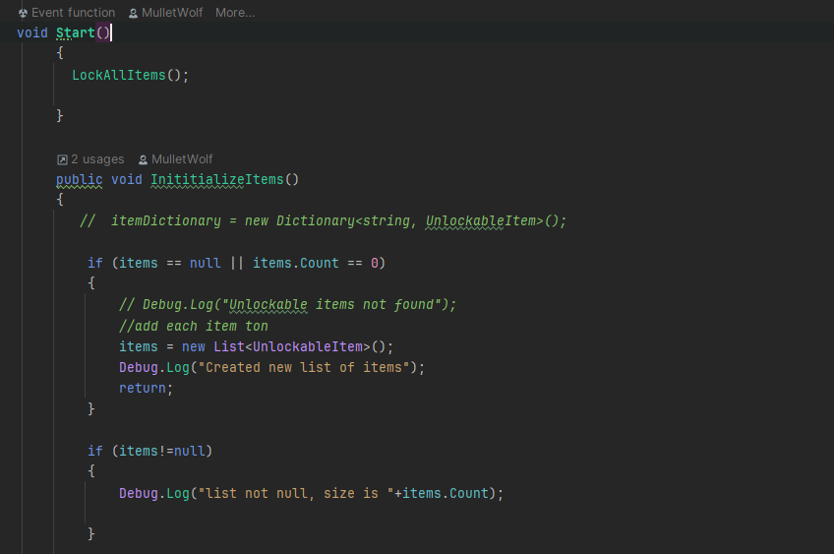

17/04

I assumed I told a teammate to integrate the sound, but she told me I only told her to look at it , and I was stressed out, so I explained a bit of it and told her to ask the person who did the audio scripts her questions, since I wasn't the one who did it.

My teammate did a new build profile that's going to be used for submission, so

 I made sure all the code works and there's no errors.It does work, it's just that when I click a painting inside the gallery, it doesn't bring you to a different scene.I have a method called UnlockSceneInGallery which checks if a painting is unlocked and ts clicked then it brings you to the correct scene.I tried using a dictionary for fast lookup, but I feel that it's better to keep things simple and straightforward.

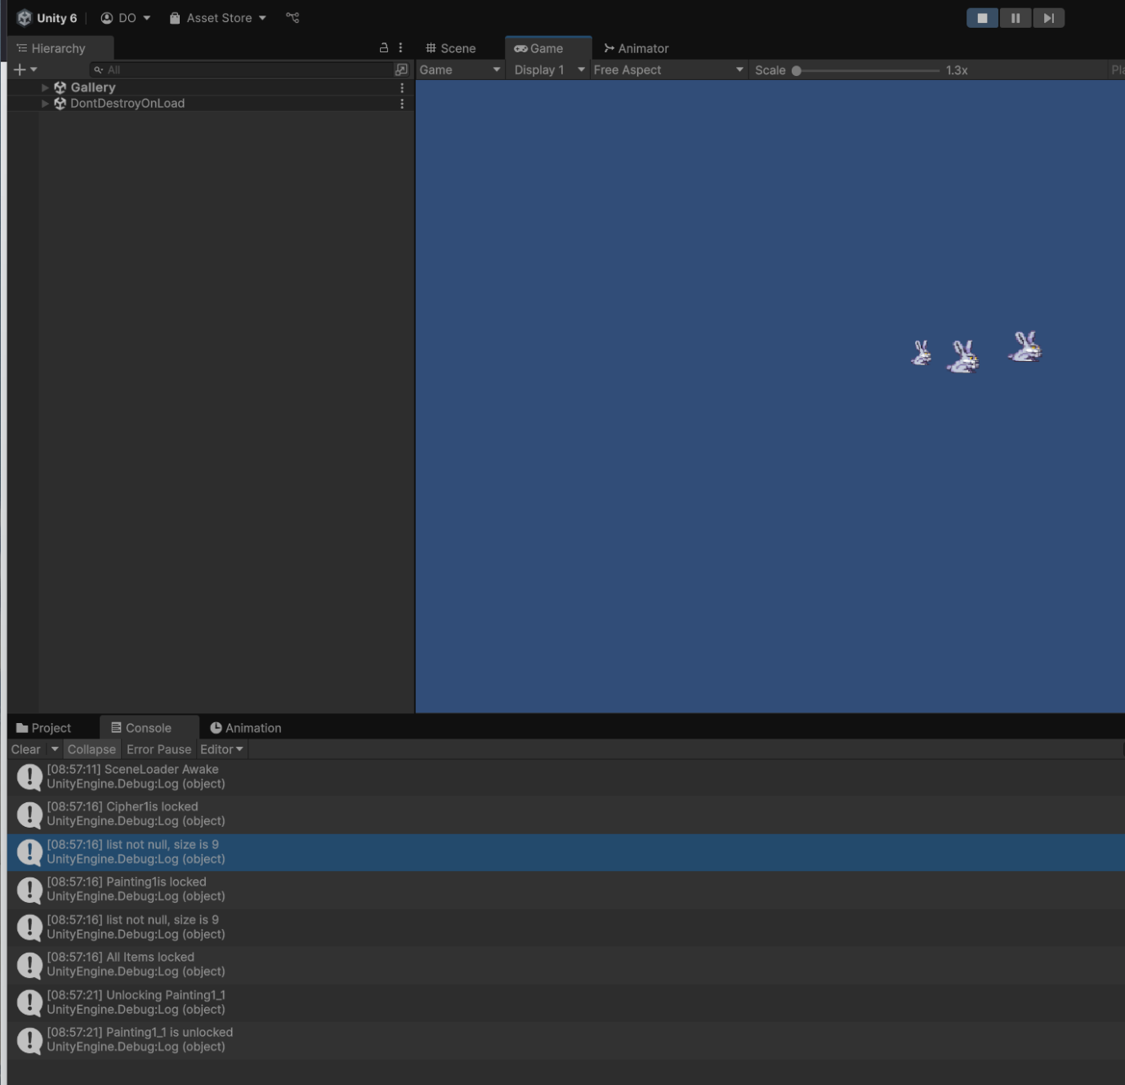

I changed this

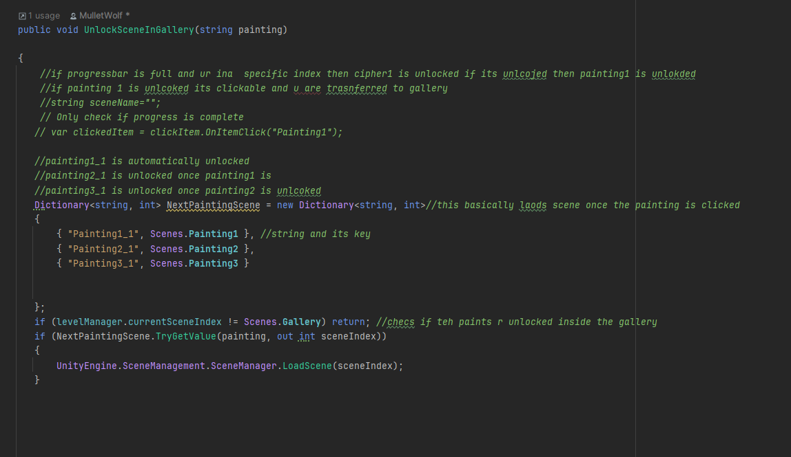

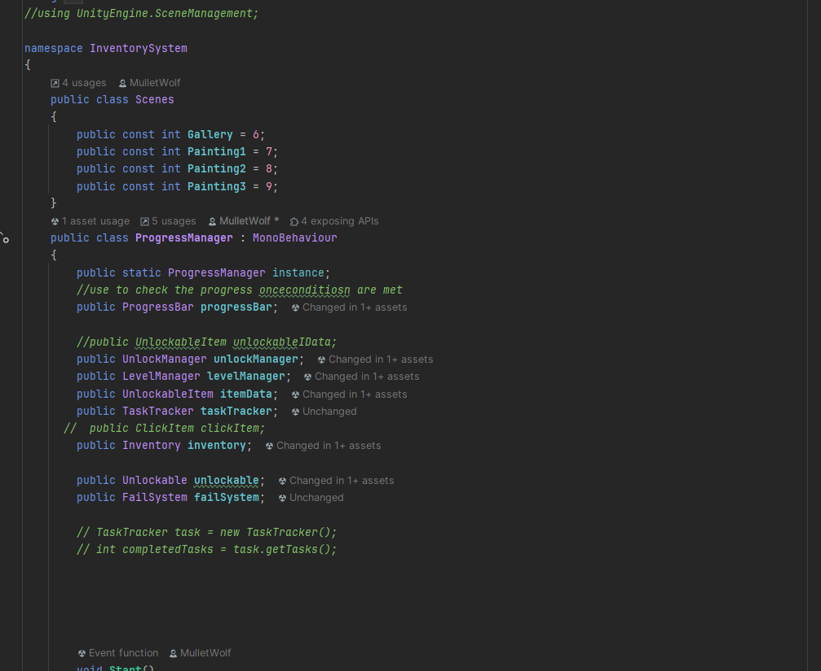

I changed it to this

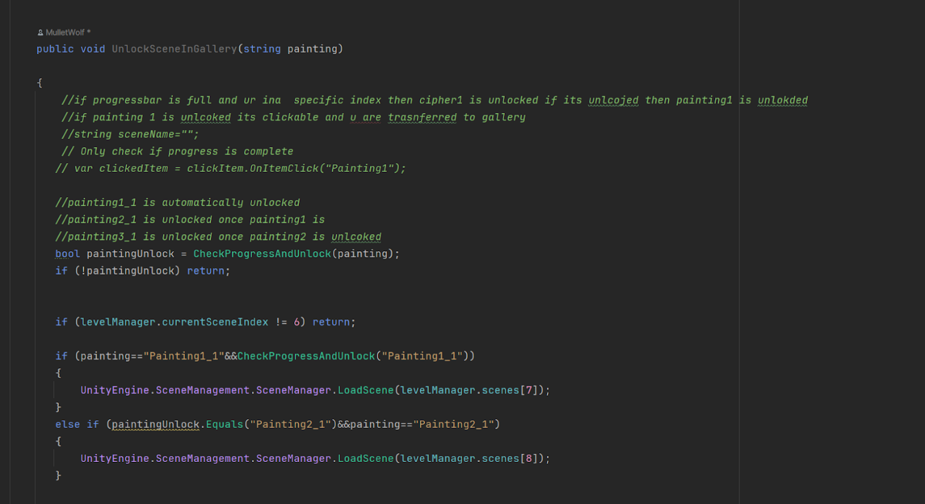

Unrelated to the code, but I told someone to work with the person doing the audio.After I looked over the audio I understood what needed to be changed.Only thing that needed to be changed was this.

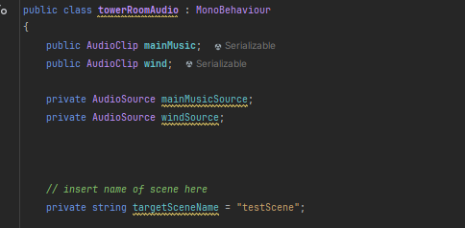

I also asked the UI developer if she was still doing the layers and animation and she told me she wanted someone else to do it, since she found it hard, so I asked one of the people doing art to help the person I chose to do the animation as in guide them.

The painting1_1 which is the first rabbit that brings you to the first painting, doesn't do anything when you click on it.

I tried manually doing it in the click item

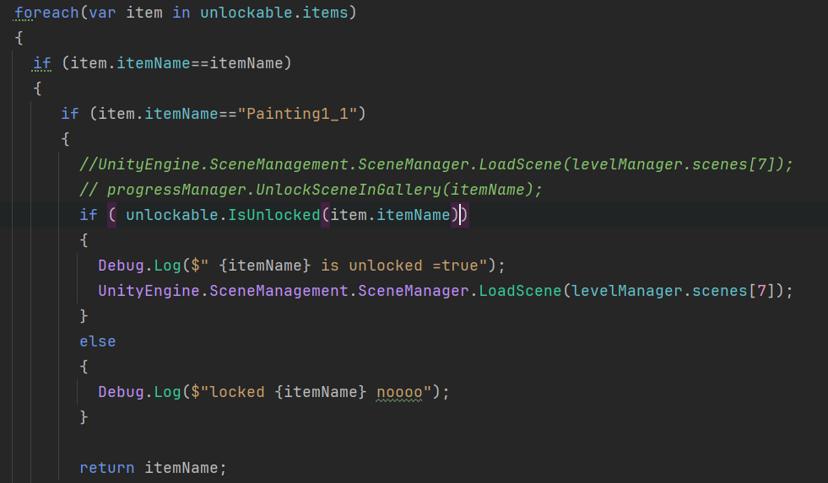

But it says

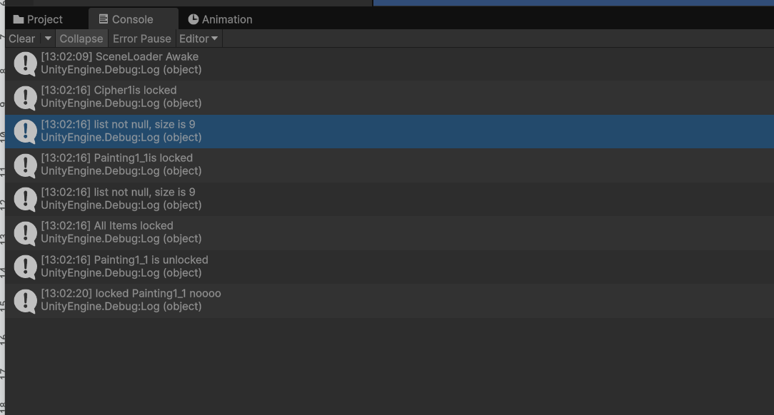

It's supposed to be unlocked. But it goes back to locked somehow.I fixed it by doing this

18/04

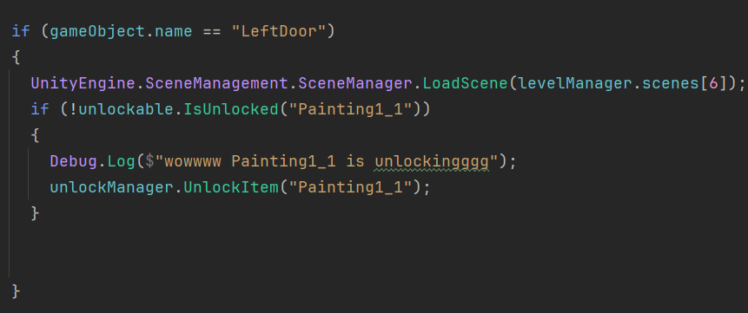

Next problem

When I click 1 cherry it says i clicked 4 ,

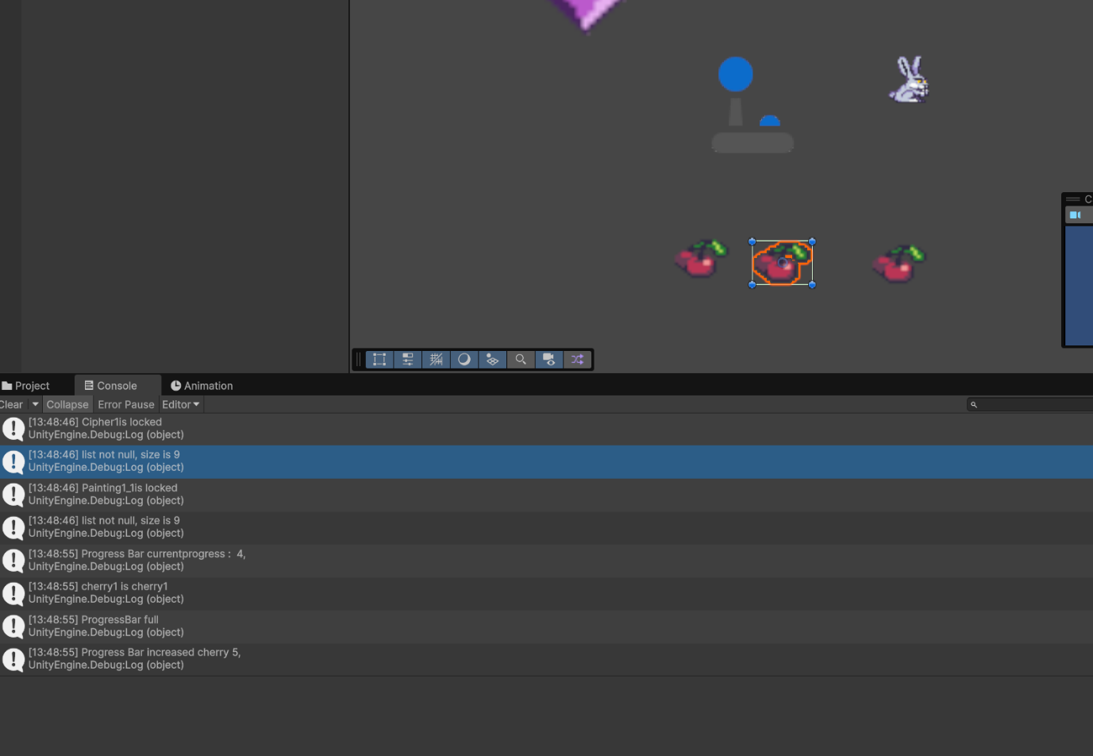

I fixed it ,but clicking on the cipher(the gem) doesn’t do anything.

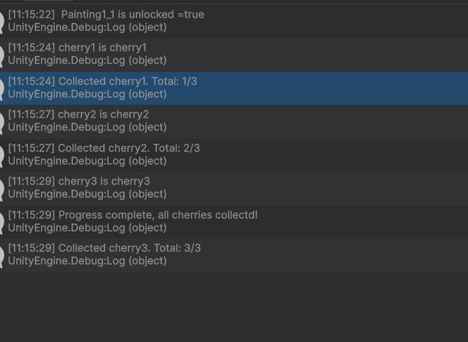

I added this

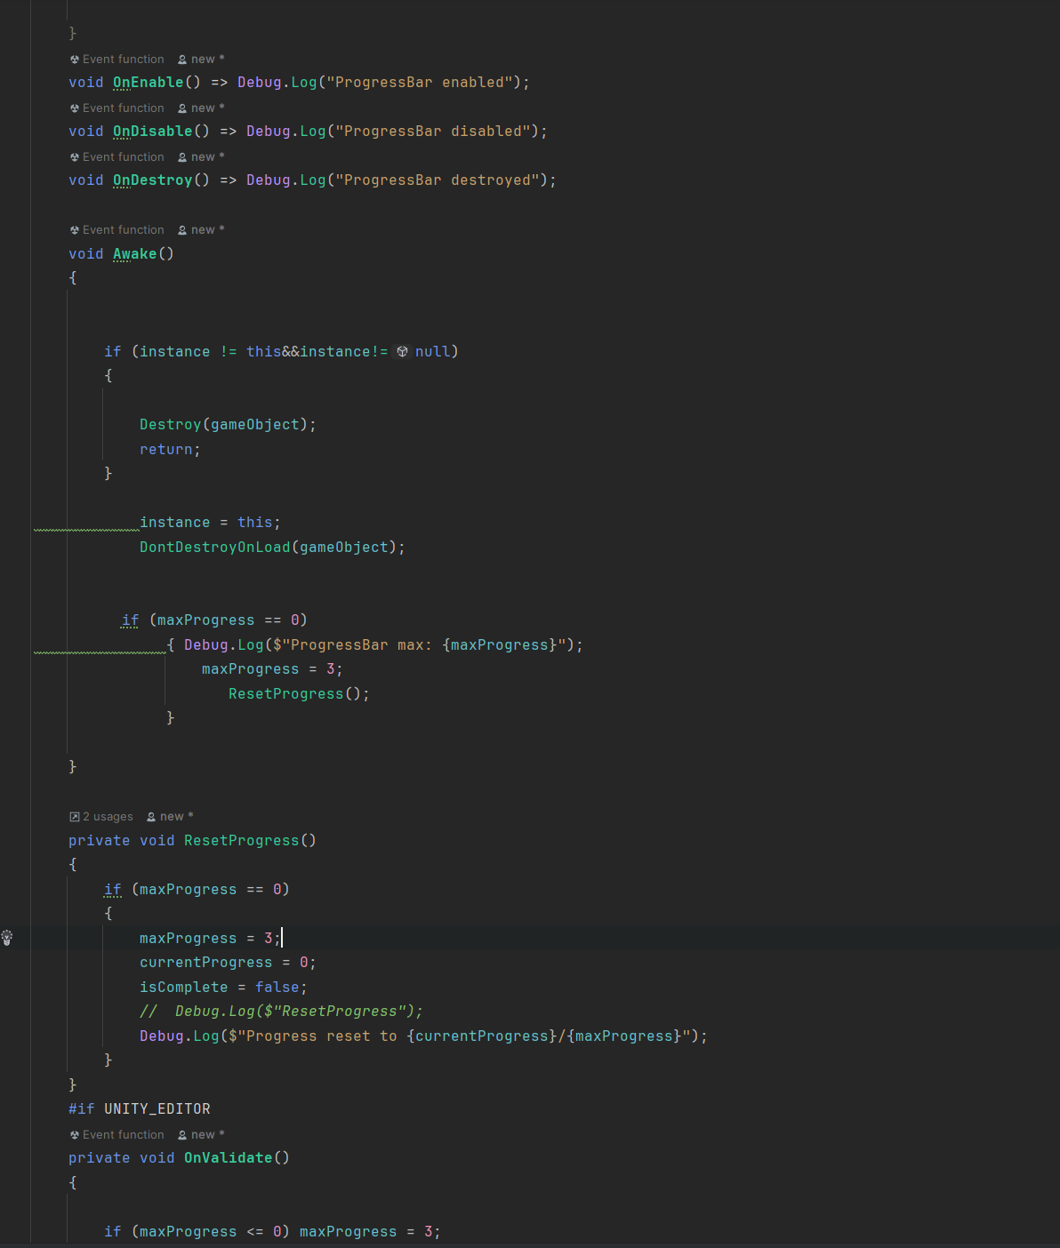

Since it was telling me that the progress bar was full,I just forced the max progress to be 3.And if the instance exists already then its destroyed.

I ran it again.Well I thought I fixed it, I didn't change anything, yet it shows this

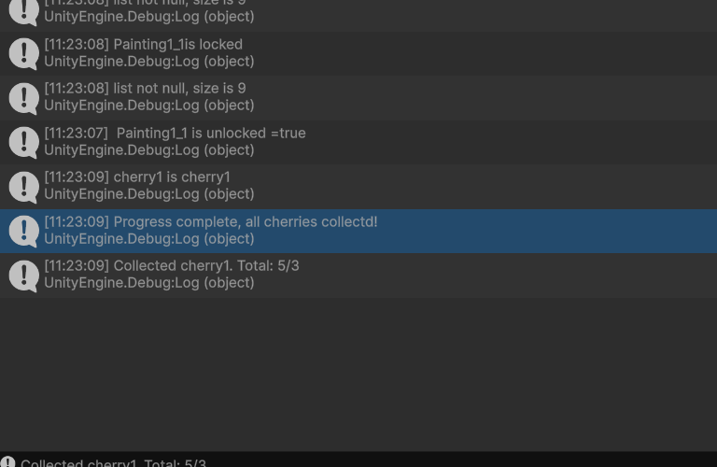

I forgot to add the instance since I referred to it in the cs .I decided to create a whole new progressBar.cs class since my progressBar is giving me problems, so I decided to create another one and stick with the basics.Thats when I realized I didn't put the progressbar instance within the progressbar. And the click item

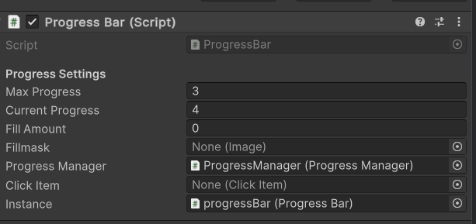

New problem



It is inside the scene, I made sure that the Type is the right ProgressBar type ,the gameobject is in all the scenes with al the reference game objects inside it, so I don't understand what the problem is

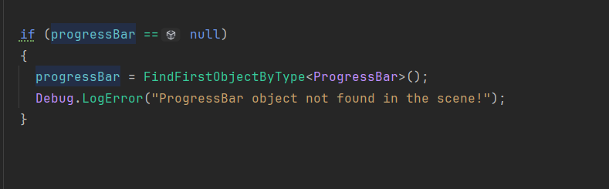

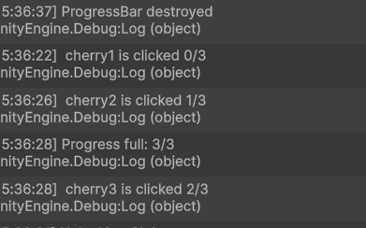

making a new progressbar worked.

Instead of having the same gameobjects in every scene ,, i just made the ones that are gonna be used in all scenes persistent between all scenes.And if teh gameobject already existed it just destroys it.

I copied this code in all the gameobjects,so I don't have to manually dd the game objects in each gameobject.

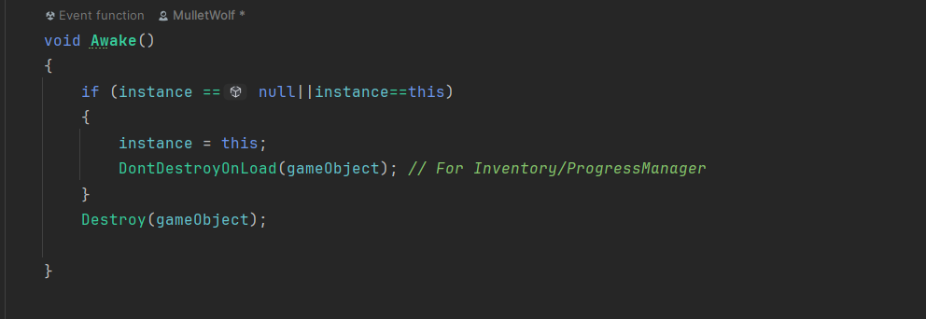

I hardcoded this , to see if it worked without HandleUnlockablesProgress.It does so I will try using the method that has all this .

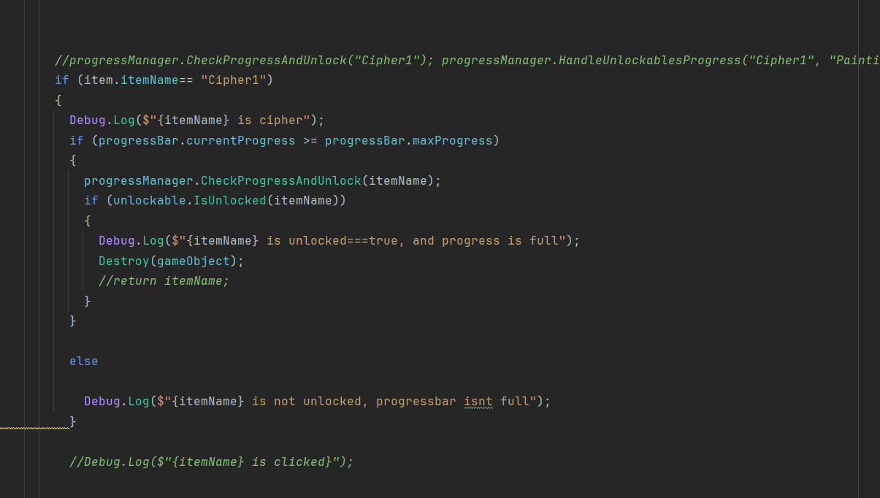

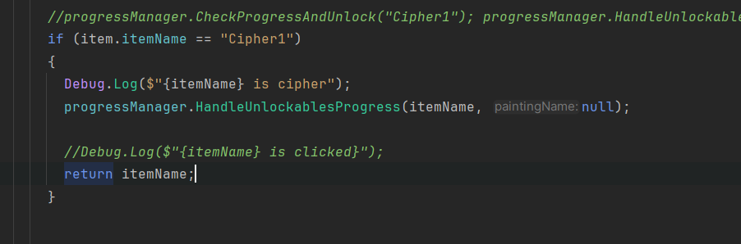

This was being destroyed because i used destroy(gameObject) in clickItem script so I just used DontDestroyOnLoad()

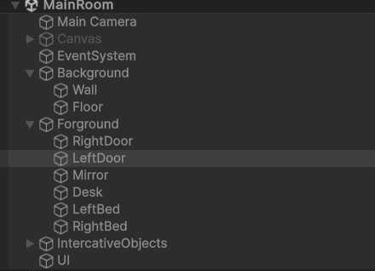

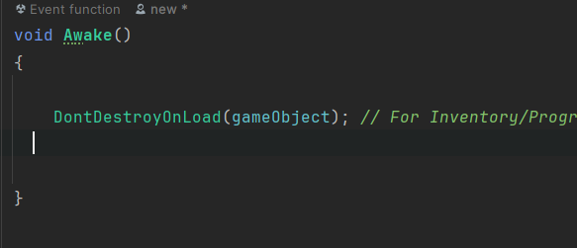

Problem

Cipher1 is cipher is supposed to say cipher1 is unlocked, item added to inventory

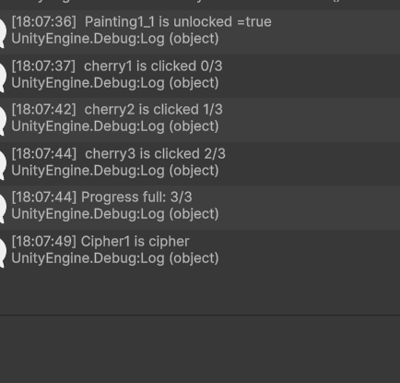

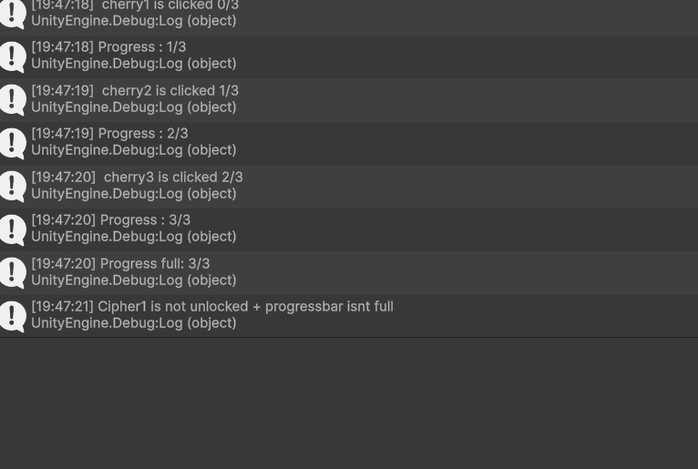

I have been experimenting with, changing the methods being called, and just hardcoding what I want after the gem is clicked to happen. I realized that when I try to call a method from CheckProgressAndUnlock its not registering anything, like it does not exist.

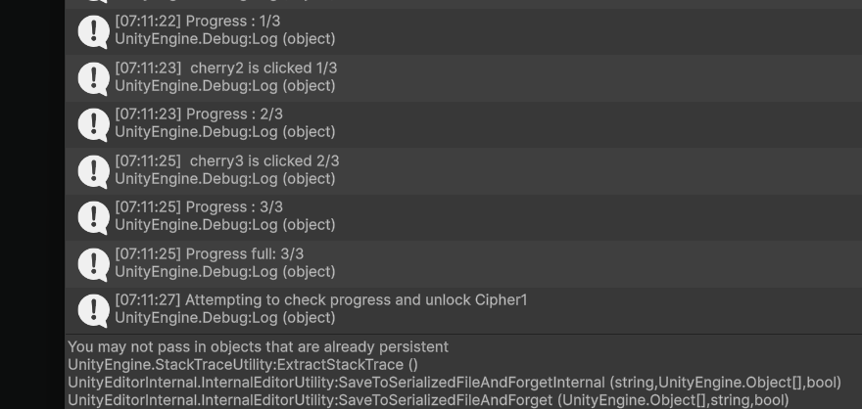

I give up, ill just unlock it without calling CheckProgressAndUnlock

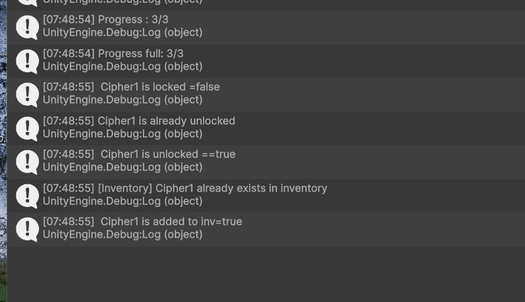

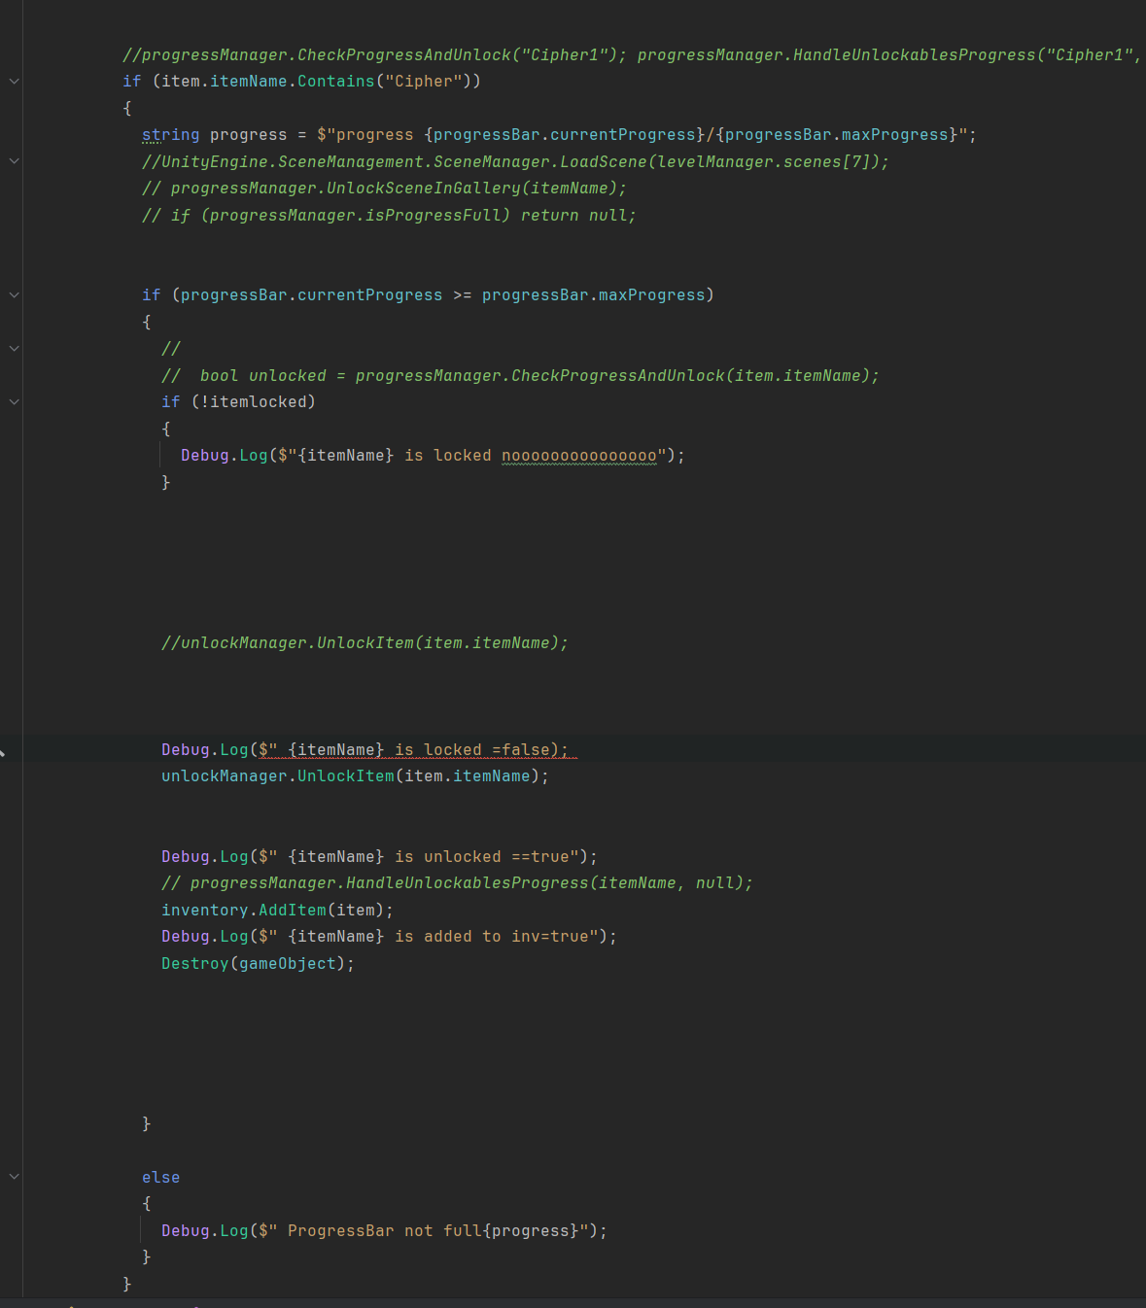

Looks like the problem was the progressManager, so I ignored it,since nothing I did fixed the problem.

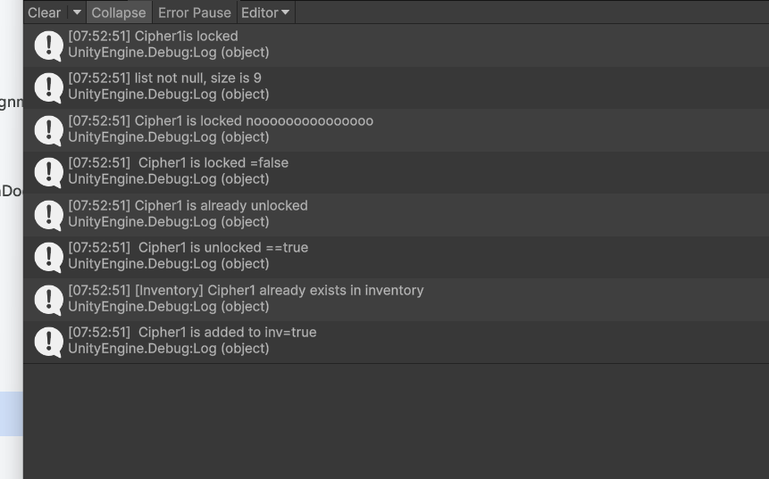

Its saying that it already been unlocked when it hasnt, so im adding debugs to check where teh problem is.

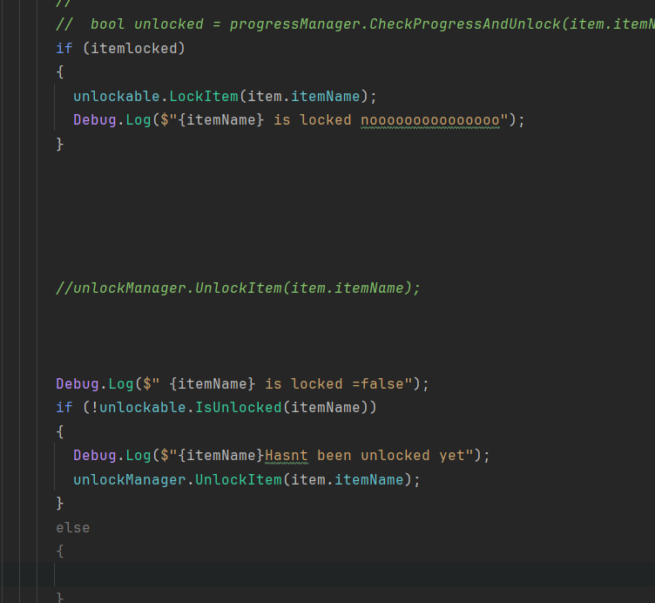

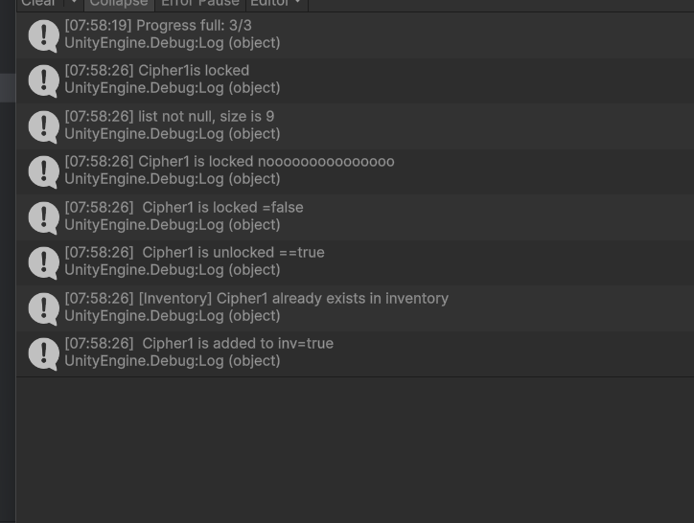

As you can see here ,it looks like there is problems in the inventory script, since its saying that it already existed when its the first time I added it to the inventory

Old inventory

New inventory

I changed it to this since, I realized that

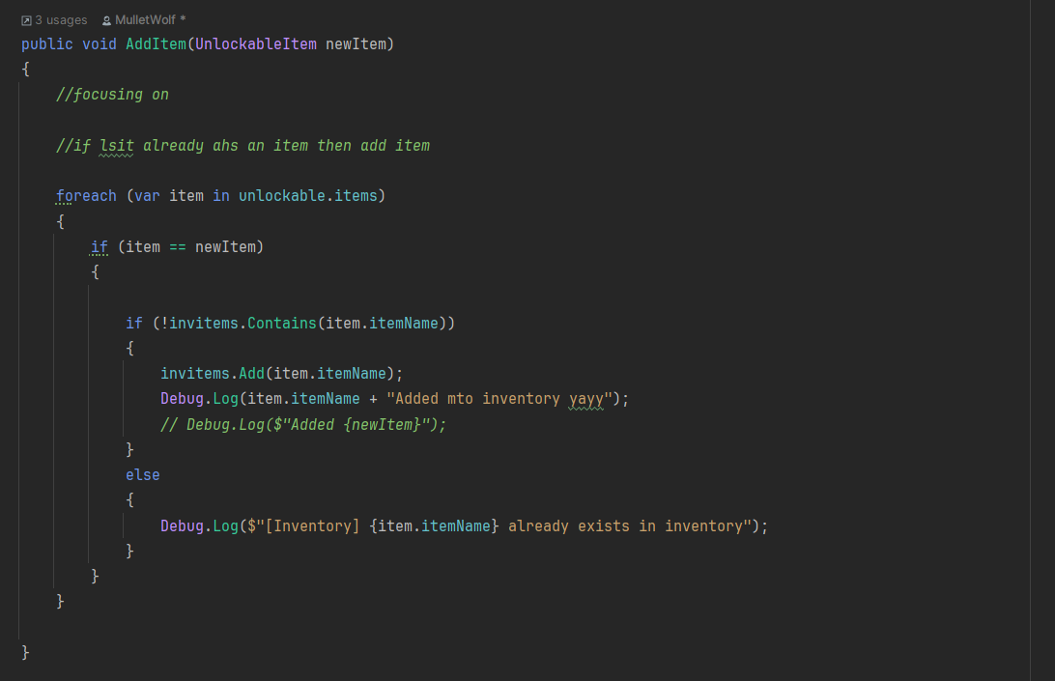

Got this

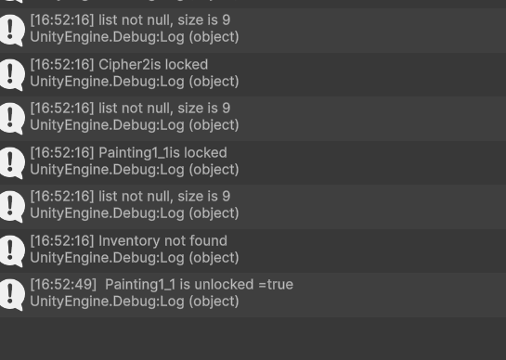

Which means the inventory is not being tracked in all scenes, so the problem is either, the inventory reference is missing within 1 of the game objects or, there's a problem within the inventory itself.

Next problem

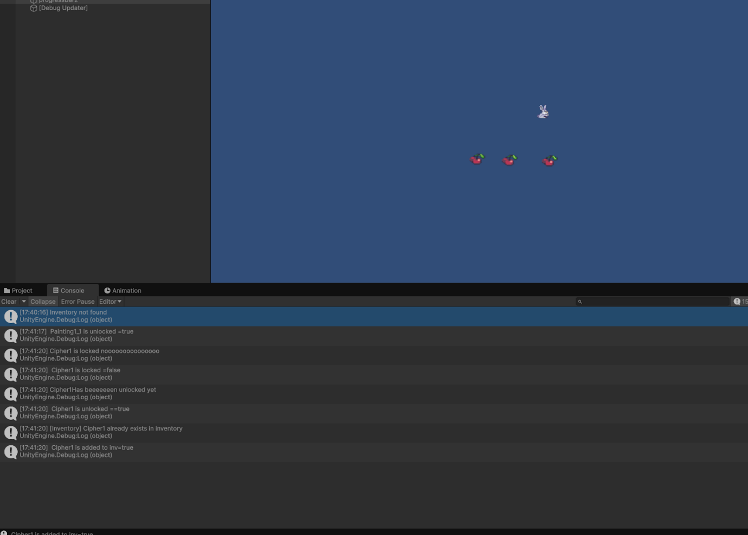

When I click on the gem before I click on all the cherries, it's supposed to say It's locked,and doesn't get destroyed, but it doesn't do that and gets destroyed before the progress bar is full.I don't understand this since I specifically said that if its less than, it returns null.Its like the cipher is already unlocked hence why it can gerd destroyed once clicked, But I specifically made it locked in the start.

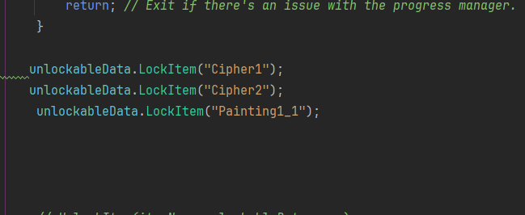

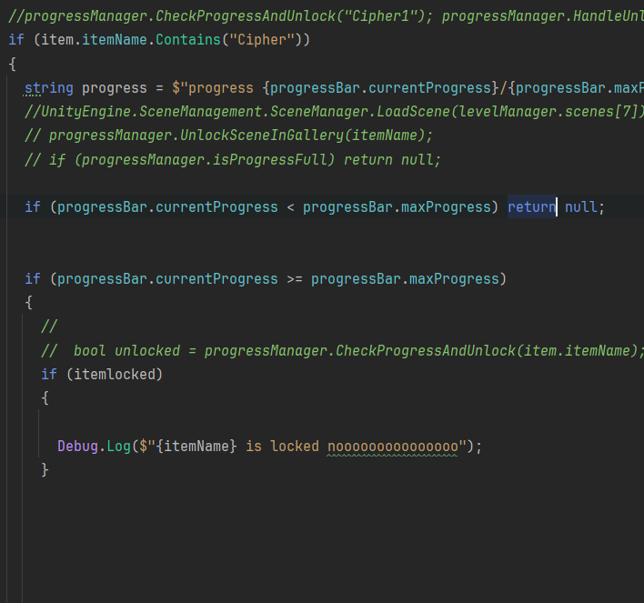

I was confused between the difference between Awake and Start,after some research Awake happens before the game starts while Start occurs after the first update.

When I put this into awake and not just start and I put if progressbar is full in the same method as unlocking.It worked, now it only gets destroyed once all cherries r full

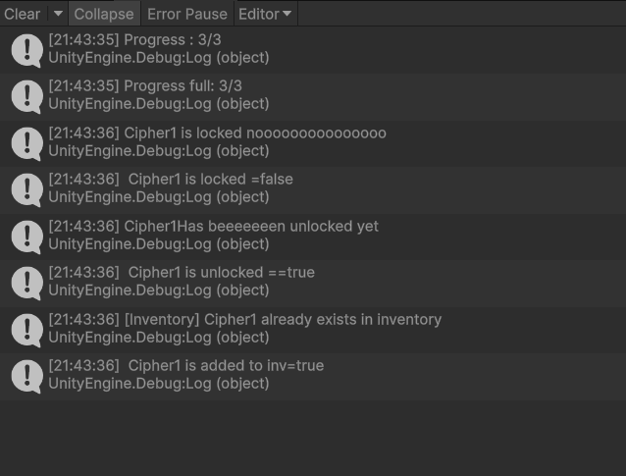

Seperate from my code, I divided the task for setting up the audio into two people since I wanted it done as fast as possible, since the person I told to do it barely made progress.1 team member told me there were errors in the unity, so I pushed the changed unto my GitHub and started fixing the errors

The problems I have

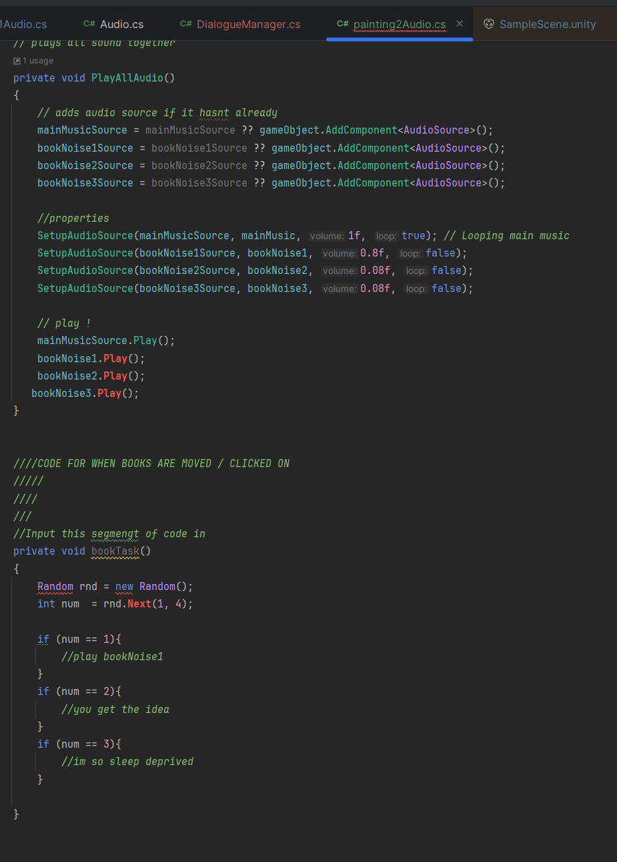

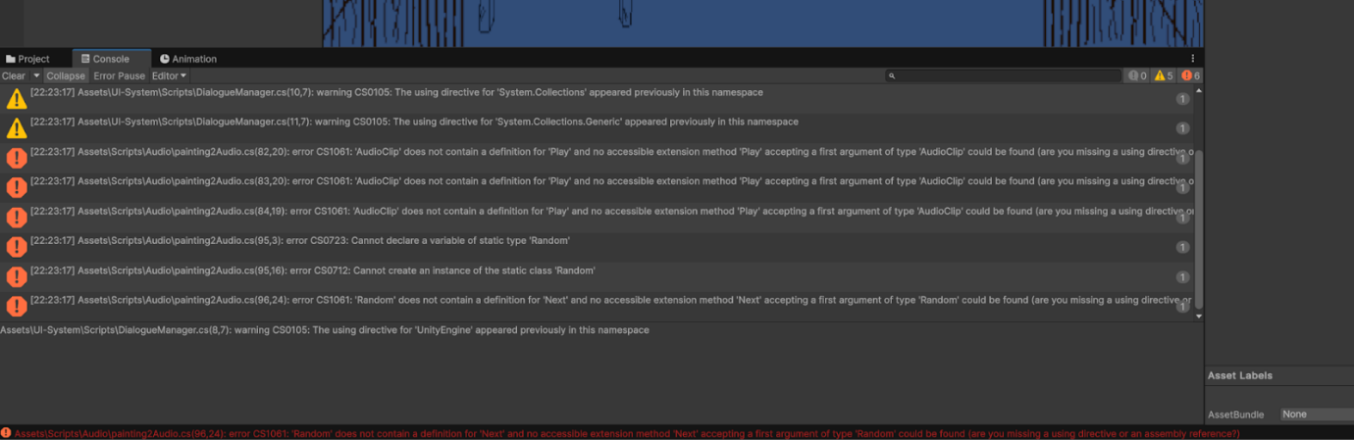

First step assigning the correct scene name into this for the audio

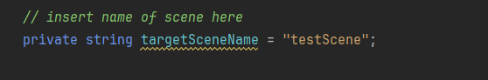

I started with teh Painting2Audio

I fixed the random problem by saying Random.Range since Random is a class not an object

I compared these 2 audios galleryAudio had no errors, I noticed that the .Play() is attached to

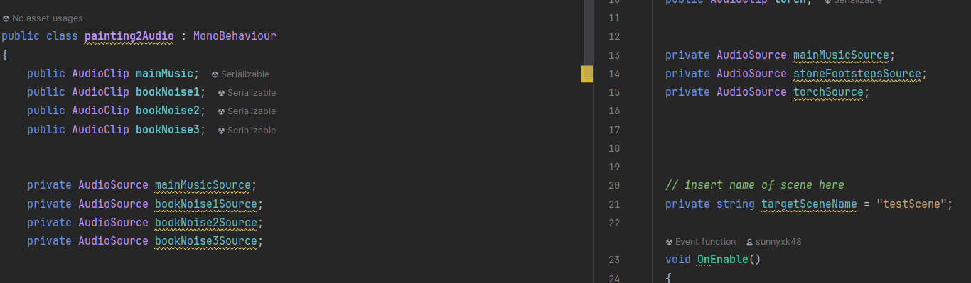

So I just replaced them.No errors.

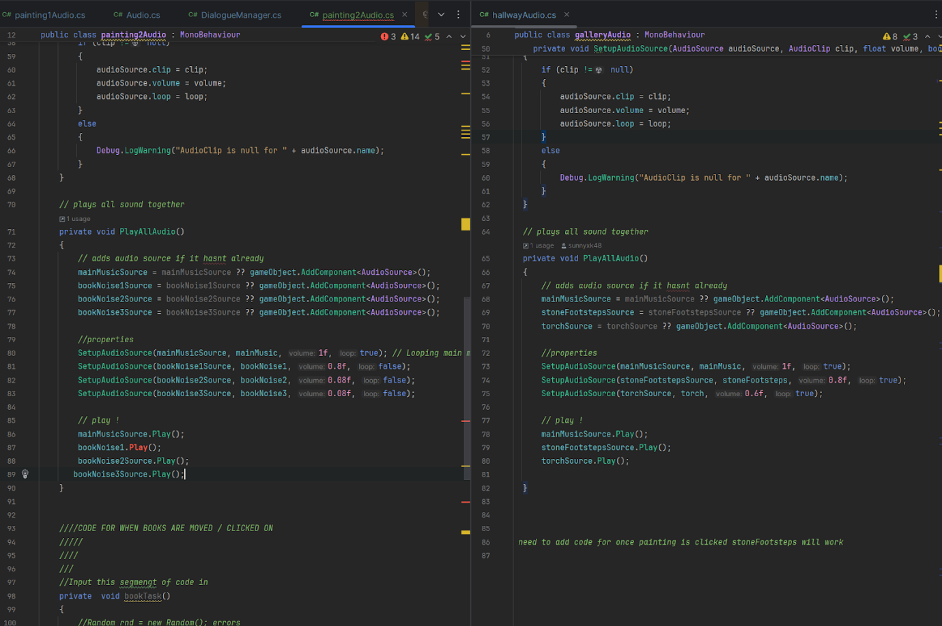

Next I told a teammate to tell me if tehy have problem,s I helped them out with their github Deskstop issue which was showing this.I told her to save her changes then fetch then commit, that didnt work since it showed

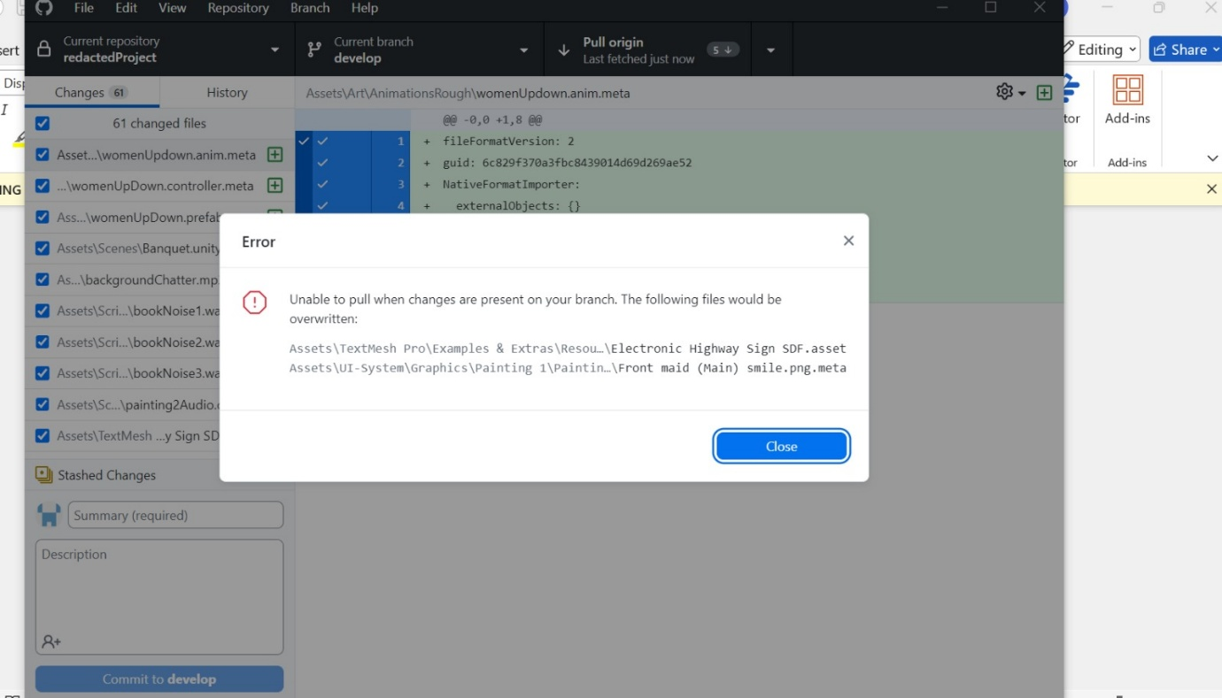

Anothe problem came up

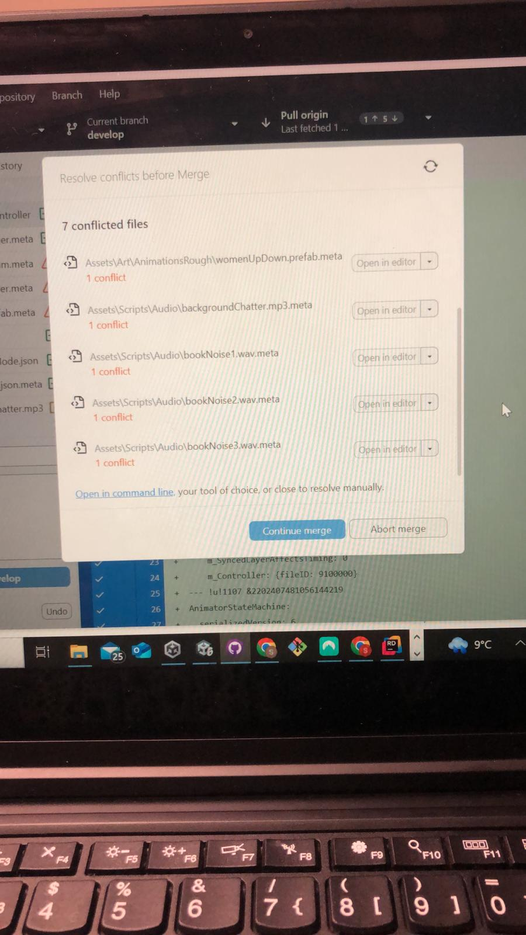

I Told her to go to task manager then end the tasks, then go back to github desktop then commit changes to github then fetch and pull the changes.that seemed to work.

I had an issue with unity wanting to use plastic4 for vs instead of git.I just deleted anything related to plastic4 from my files.

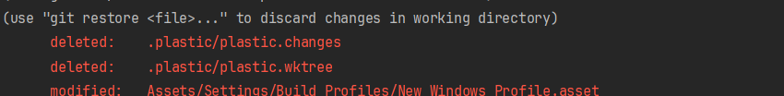

Wk12

New problem is not saying the object I made locked within the console, When I click on the cipher before all the cherries it says it's unlocked.

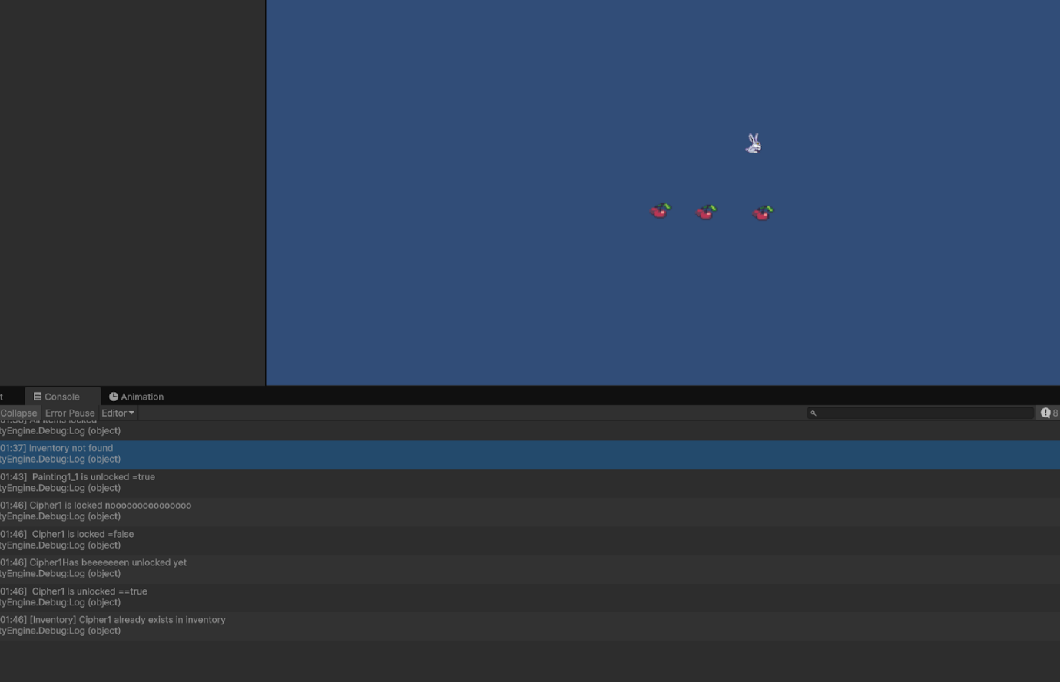

I have been hard coding it since the checkProgressAndUnlock method refuses to register after the first line.

Cipher problem fixed the code

New problem

Painting1 ist unlocking at the right time (after the cipher1  is clicked)-to bring player to the inventory)`, when i click on progressbar it does increase , that was fixed.But the problem is that

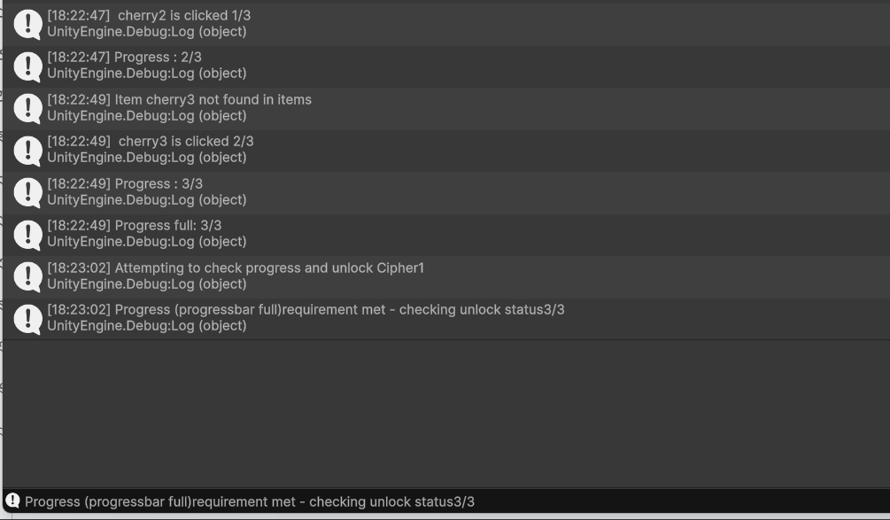

Not a code problem

I have been helping the new teammate with setting up the audio into the scene. She faced a lot of problems when pulling changes to her GitHub desktop, since she didn't understand many things and needed me to tell her what to do. Theres not much she can do ,since all the code has already been done.

Week12

—------

Here cipher 1 is unlocked before the progress bar is full

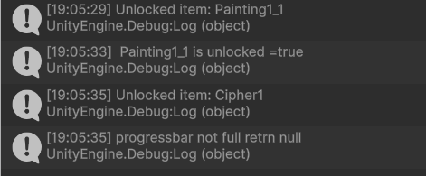

I used this, to check if has been unlocked when i press play. It says true which means that it is unlocked ,it's supposed to say false since i made sure they are locked using .I checked i items refers to the Unlockable items(it does),

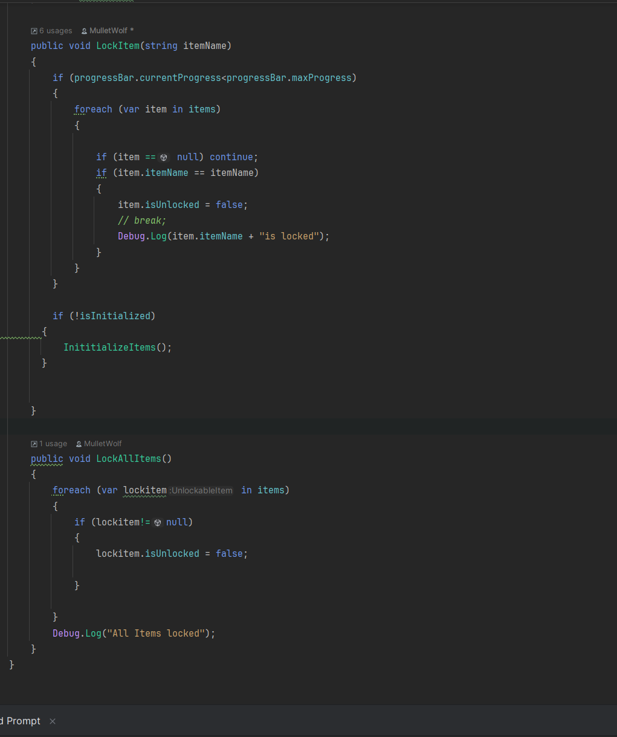

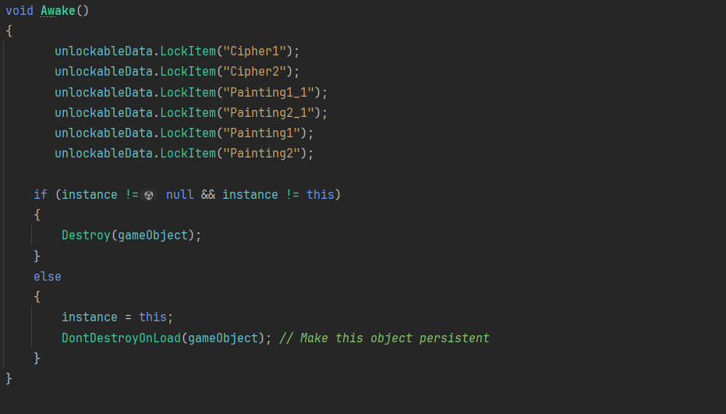

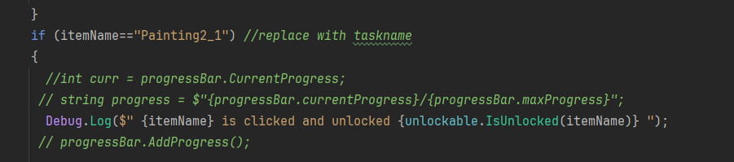

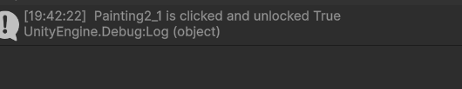

I fixed it , the problem was this.I was saying the itemName is true, and returning the name itself not actually returning true when it check=ks if isUnlocked is not true;

Old version

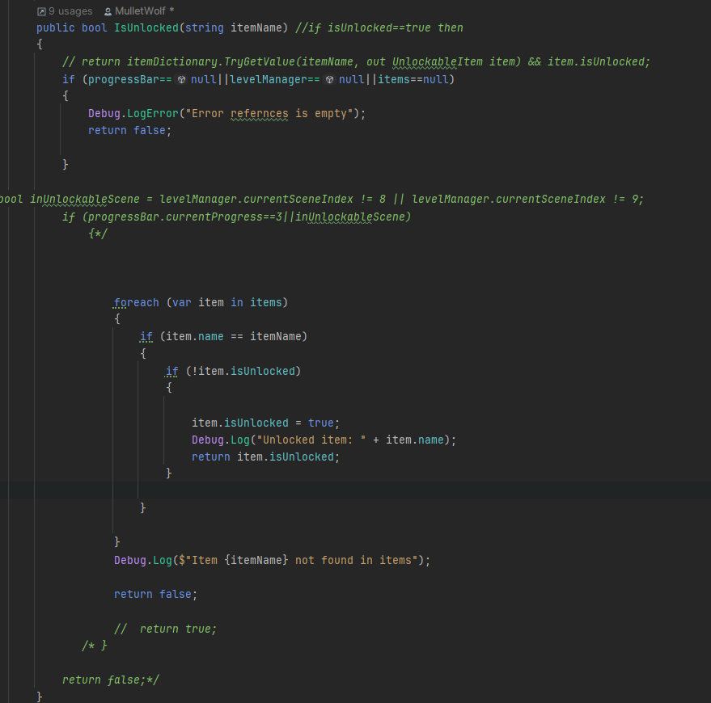

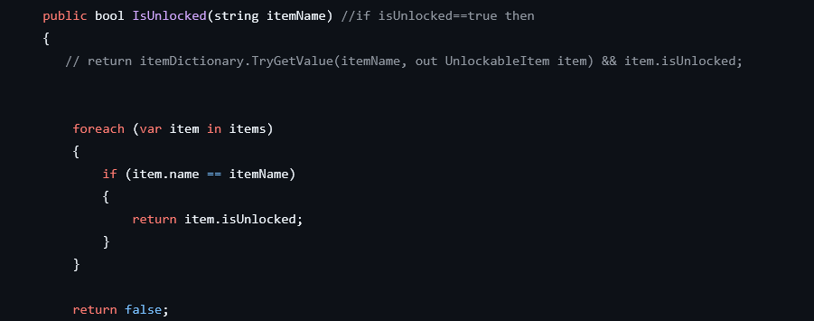

Fixed version

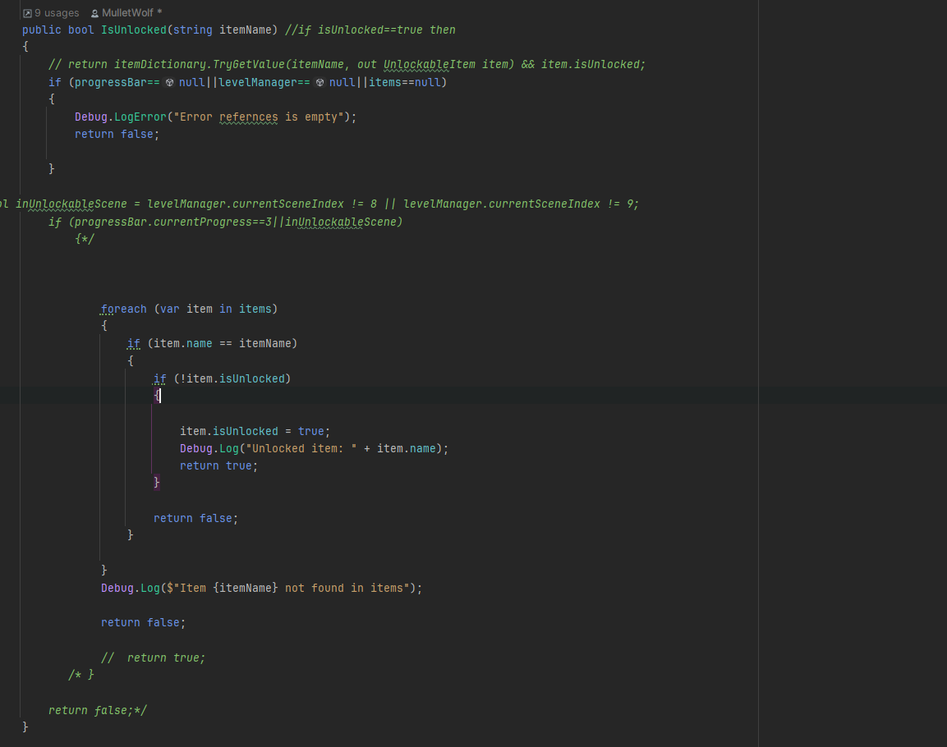

Result

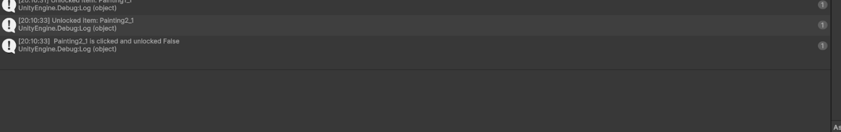

I also removed this

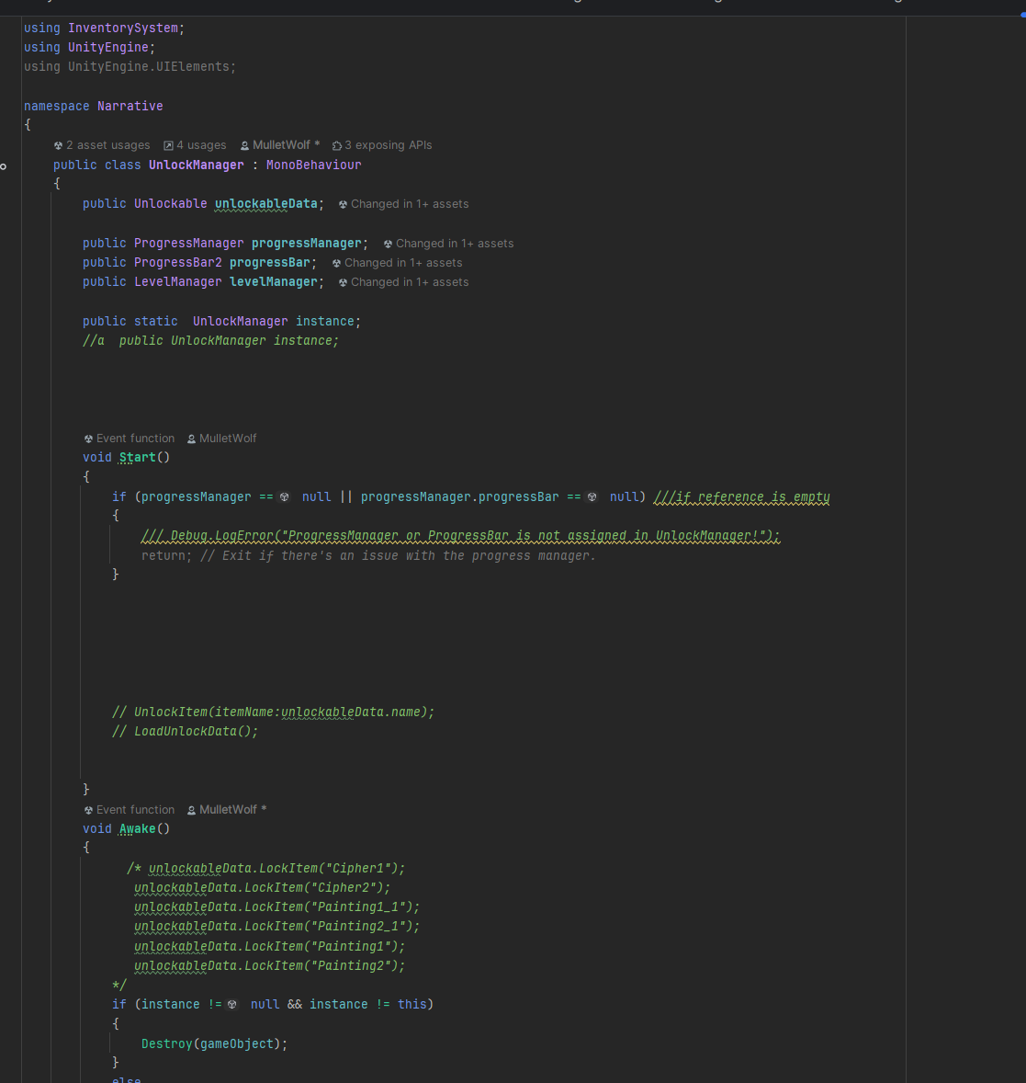

Since LockAllItems was already doing the locking, and theres no point in doing it 2 times.

Decided to cross out SetUnlockItem since its the same as IsUnlock.Better to use one method for all the unlocking.

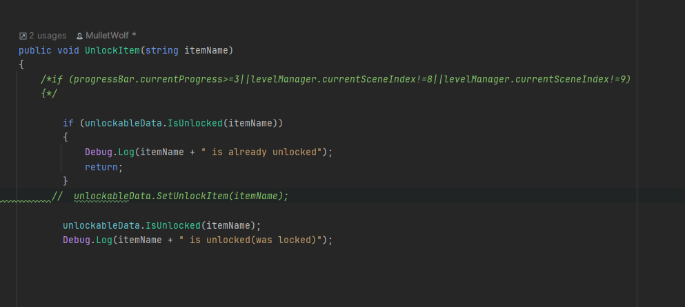

Comparison

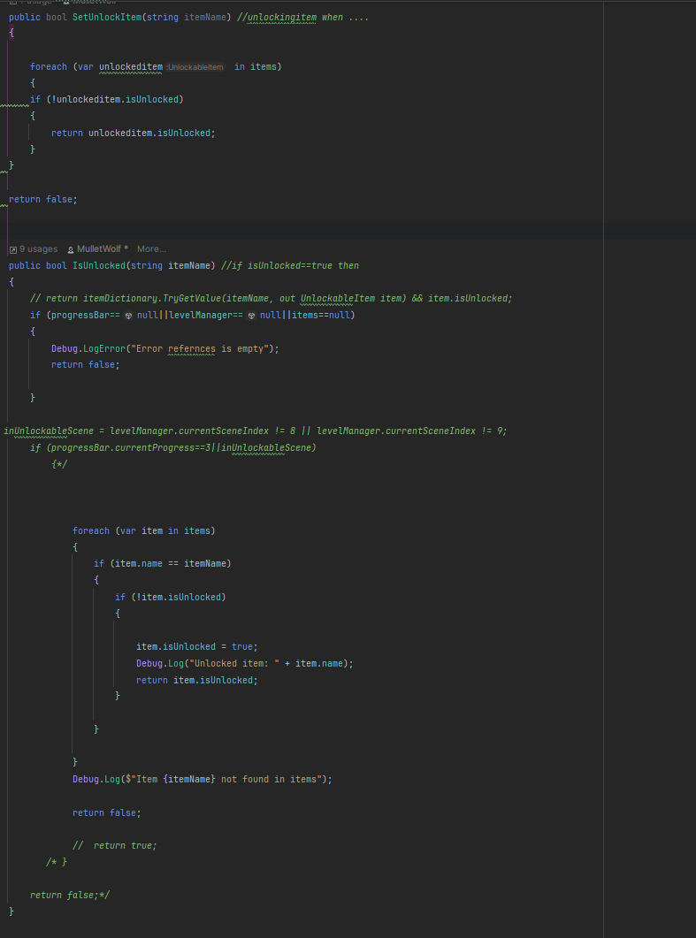

The unlocking system seems fine now, its locking all items at the start,and before I unlock it using a condition it does say that it is locked.Now I can fix up the painting1 scene properly now.

New problem

It says that the Painting1_1 which is a painting in the gallery that brings you to scene 1 is not in items list.

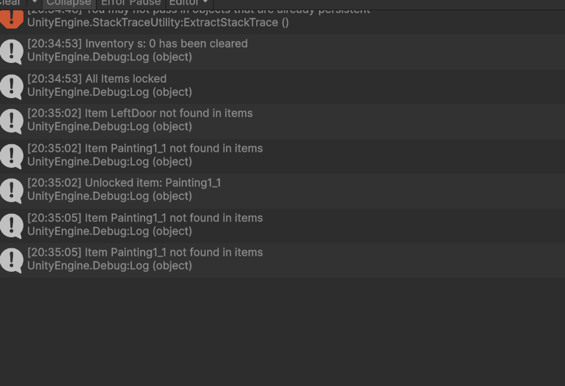

Figured out the problem,I forgot to call this method in Awake ,it ensures that if the list is null, it creates a new list of the items.

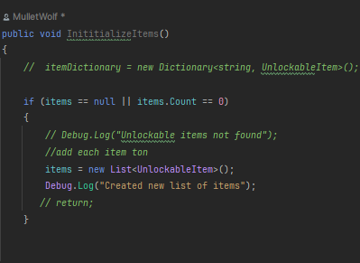

It didnt fix it

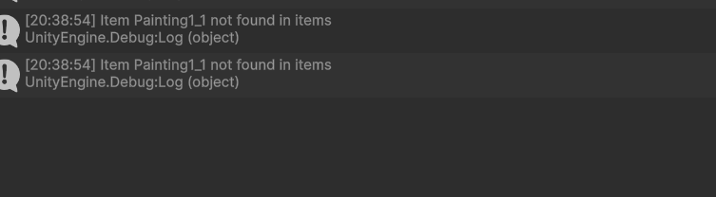

I figured out the problem

I used the Debug.Log to compare the item clicked with the items inside the items liste, to see if the item is inside or not

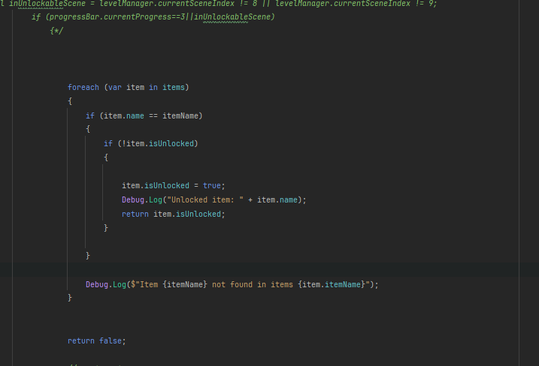

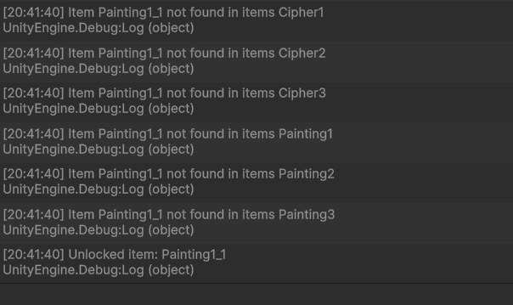

This made me realise that none of the Paintings in the gallery is inside the list.

It says the size of the list is 9

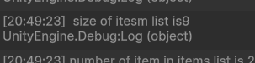

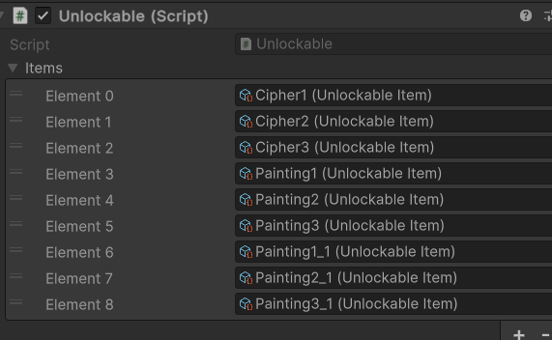

But also says  the individual items in the list is 7

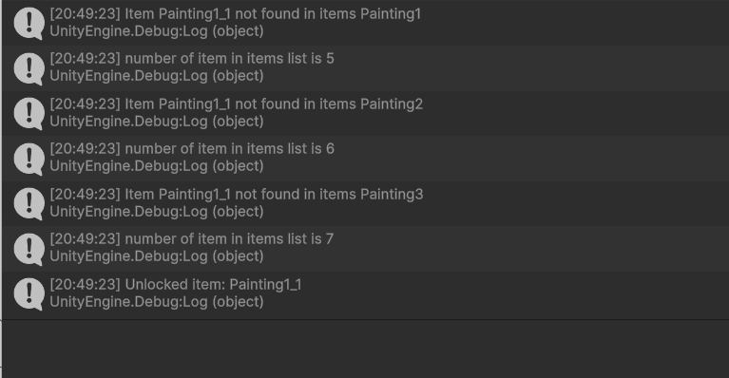

I need to make sure that Painting1_1 etc is being registered in the list.

It's not being registered,so I ignored it and moved on.

Fixed the Painting1_1 problem since because I fixed the unlock problem ,now when I say this

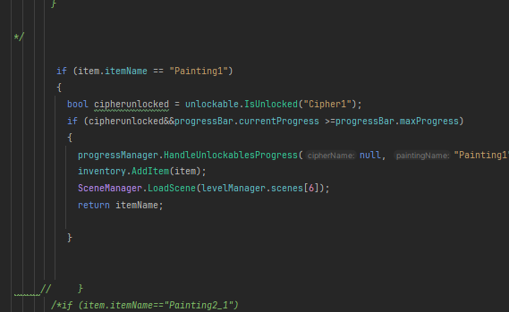

It does what its supposed to do which, when cipher is unlocked and progressbar is full, then it brings you to the gallery

I just relaized my problem I ws treating isUnlokced as an unlocking method instead of a checking if its locked or unlocked method

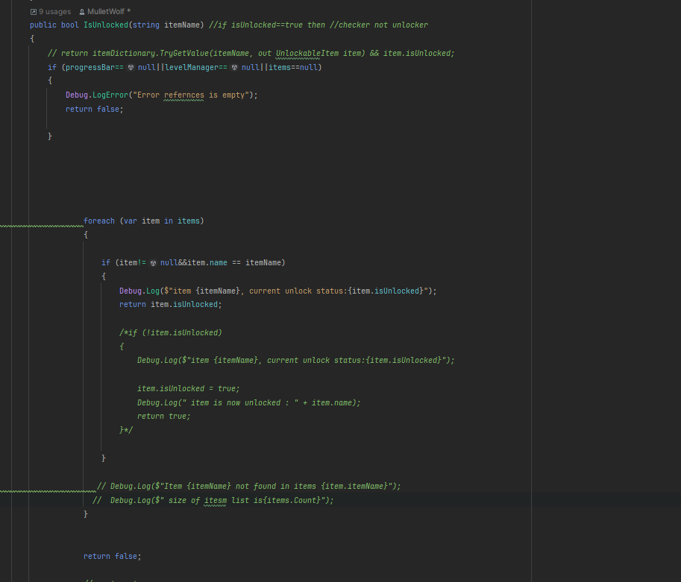

It makes sense that my problem was here since in the console it was saying “item  is unlocked” when the progressbar is not full,which got me confused.This method just returns the unlock status of the item. If the item is already unlocked it returns true, and if item.isUnlocked is false it returns false.

The SetUnlockItem ,before I never used this method, since I didn't believe I had a use to it,but now I understand why SetUnockItem is different from isUnlock.SetUnlockItem makes teh unlock status of an item true when it is false, once SetUnlockItem is called.

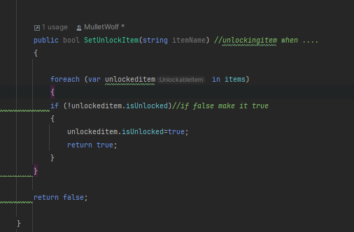

Before I used IsUnlocked which caused me multiple errors but now I understand that I should be using the SetUnlockItem method.UnlockItem is used to actually Unlock and item not set the status.

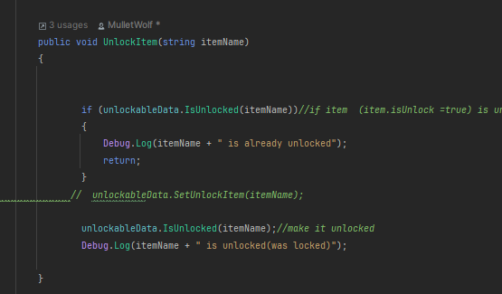

I want it so when I click on the door that brings you to the gallery, the painting1 (first painting in gallery is unlocked)

I was so used to using Load Scene(scenes[])  that I forgot you can just say 

It's saying false because it’s not registering that it is inside the list, so I can just say if it's not in the list then I add it. I must make it so that it only adds items that contain Painting or equals to Painting1_1 or Painting2_!, since the list isn't registering it.

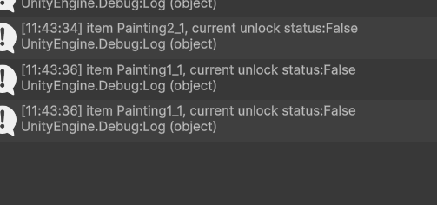

which is weird since if I manually load it using .I used Load All since I wante it to automatically laid the scriptable objects within the ScriptableObjects folder under Resources, the moment the game starts. Since then, I tried to check if it was in the list or not. It says that the itemName isn’t in the list, even though it was.

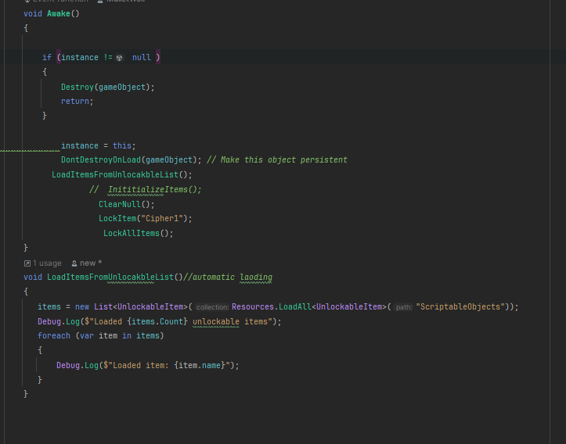

It gives me:

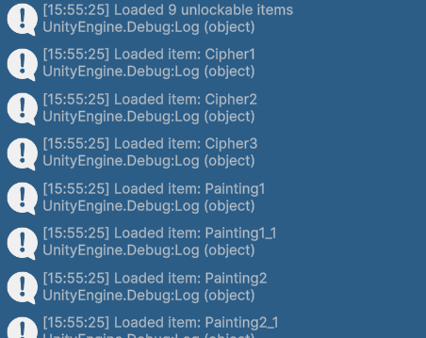

New problem:

Saying item.isUnlocked=true when I first run the program

I fixed it by calling the methods after DontDestroyonLoad instead of before it.

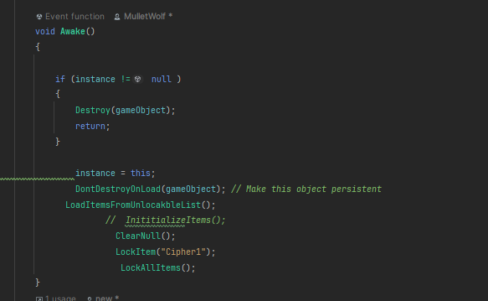

Now when I click on Painting1_1 (in gallery) and when progress bar is full, the ciipher1(gem) becomes unlocked which makes Painting1 unlocked , then it brings you to the gallery.

Now I’m going to change this, it uses  the methods inside the progress Manger, for reusability.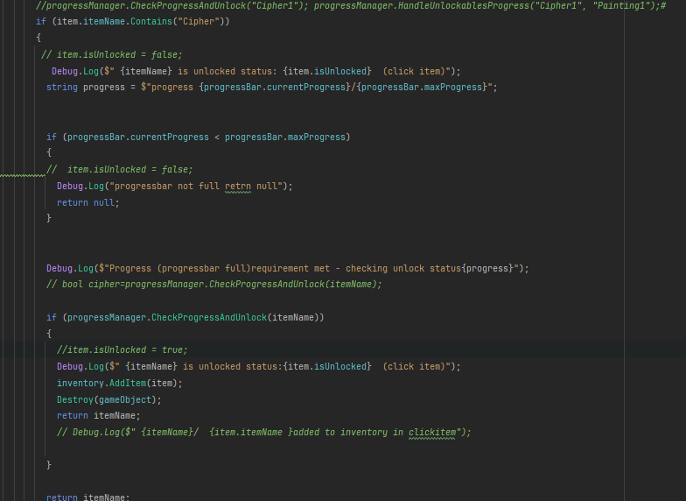

Problem I tried calling this

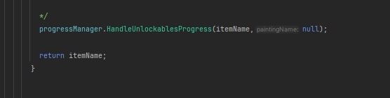

But I received this as a result.

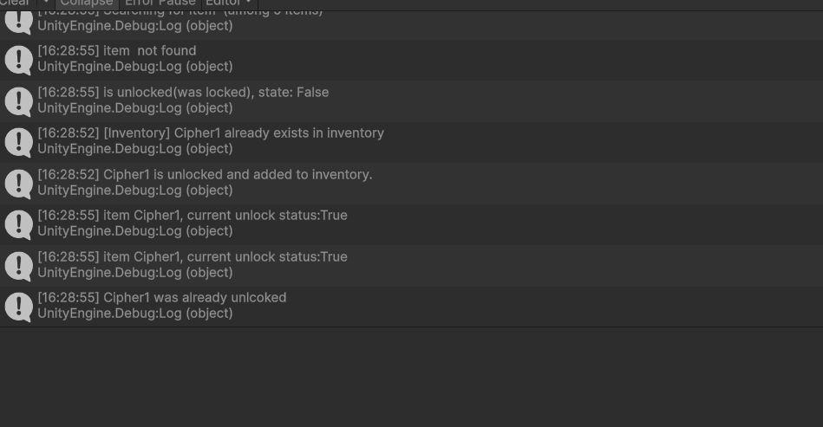

I am going to stick with the original of cipher and painting

There was merge errors so I was just using deep seek to help me, since I have no idea how to fix it

After pushing my changes, and I went to change the fake scenes I was using to the ones that we are submitting, I noticed that, there wasn’t layers, and I need the background image in different layers, so I can click on them. Instead of waiting for my teammate to respond to me, I decided to just change the code to match the scenes.

There were errors when I told my teammate to push her music sound changes unto GitHub. I tried to help her for a bit, but she had some merge conflicts, which I don’t know much about, so I just told  her that I would manually add the sounds with the right game Objects

Her problems:

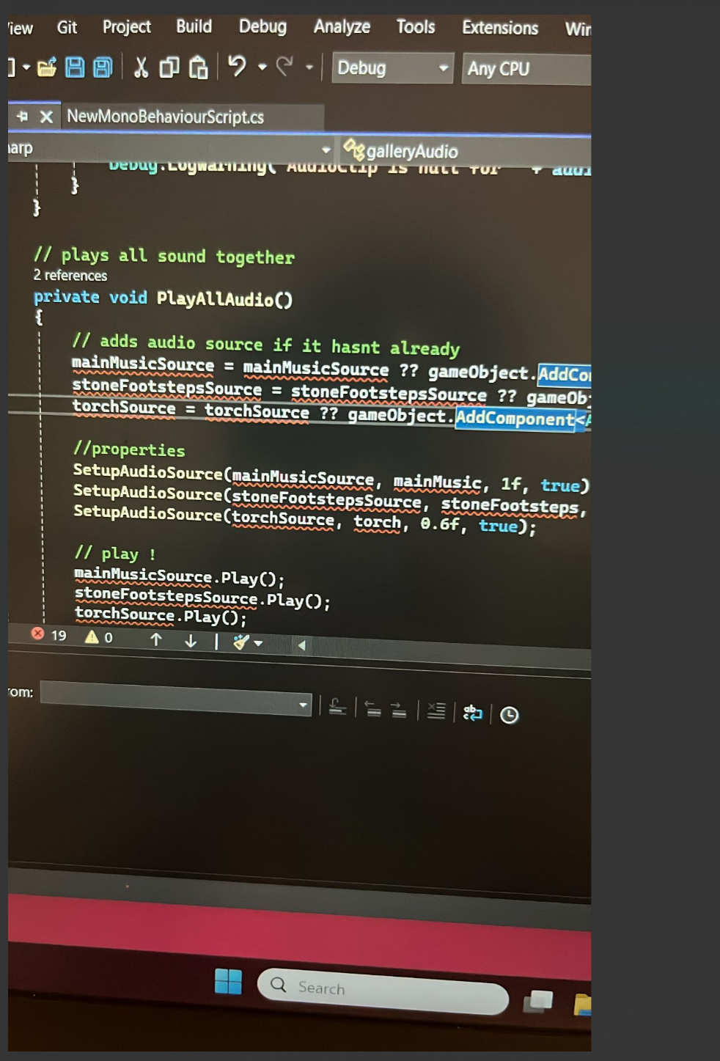

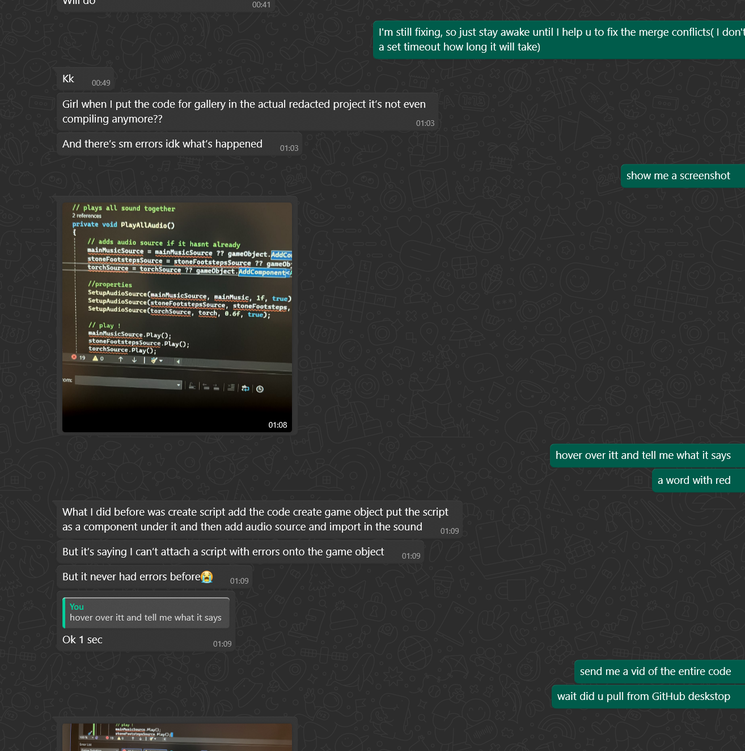

After a while, I had to tell her, I didn’t understand the merge conflicts.

Then I pushed my changes to GitHub, started changing my code to match what the UI developeri(her job is the UI) had done. Adding the right game objects to the right scenes, placing invisible game objects in front of things (since the scene is a pdf not in different layers, which I hoped), that I want to be clickable.

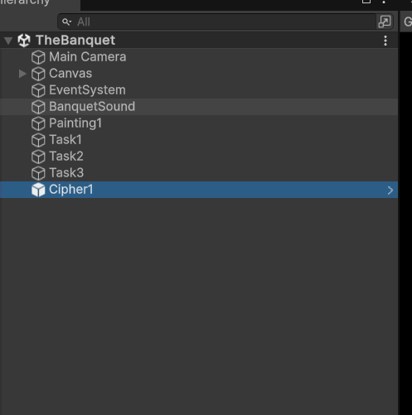

Problem

I can’t move gameobjects in my scene

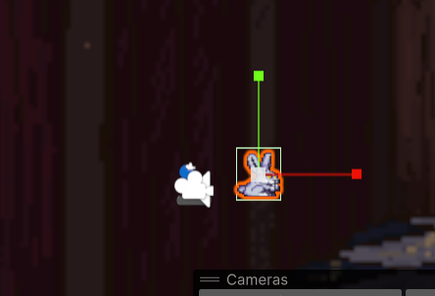

I just decided to leave it as it is,and hope that after the compile errors are gone, then it will work.

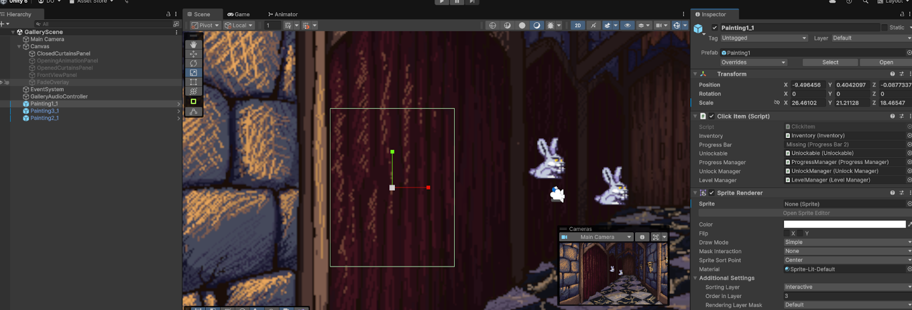

The UI Manager gave me the job to make the blacked out maid become coloured once clicked, its uses UI so box collusion and onMouseDown won’t work, so I have to use

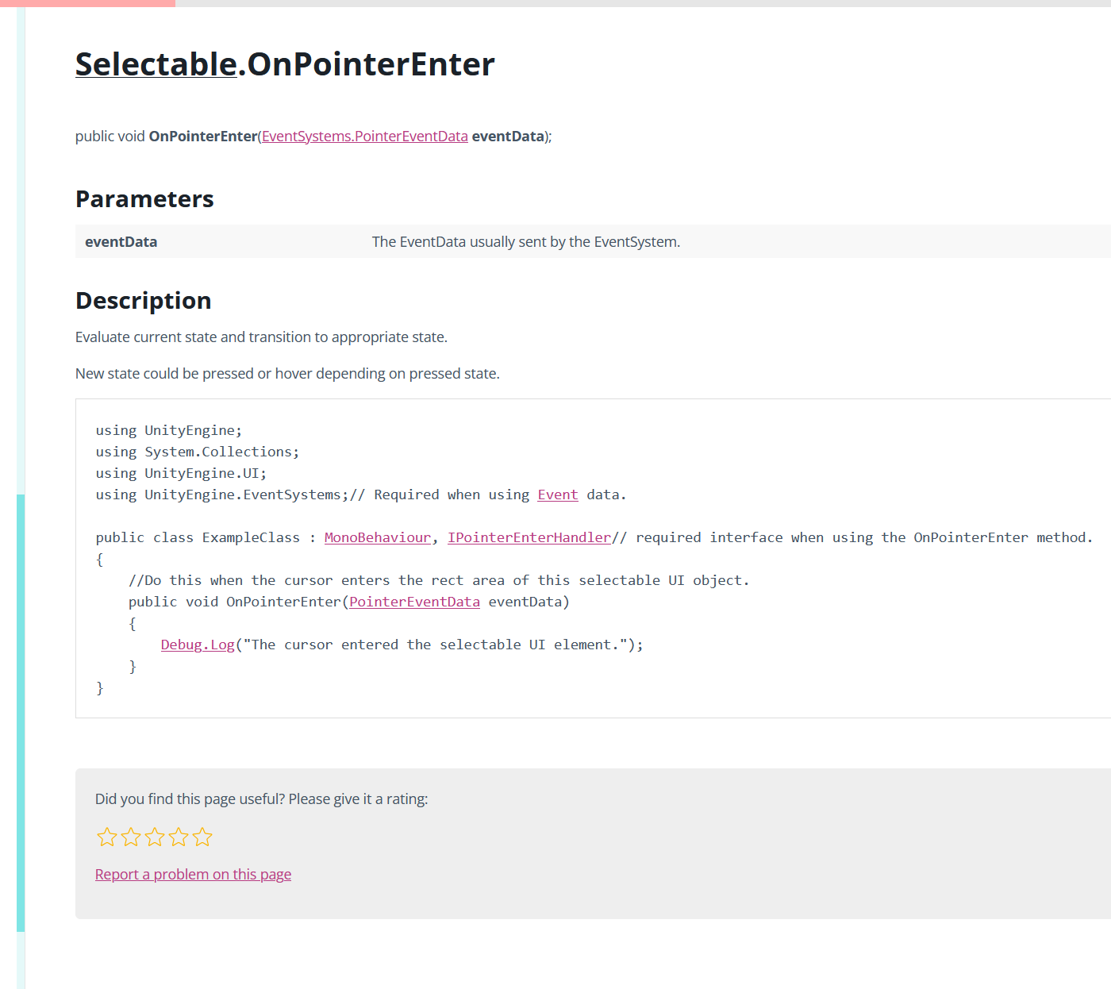

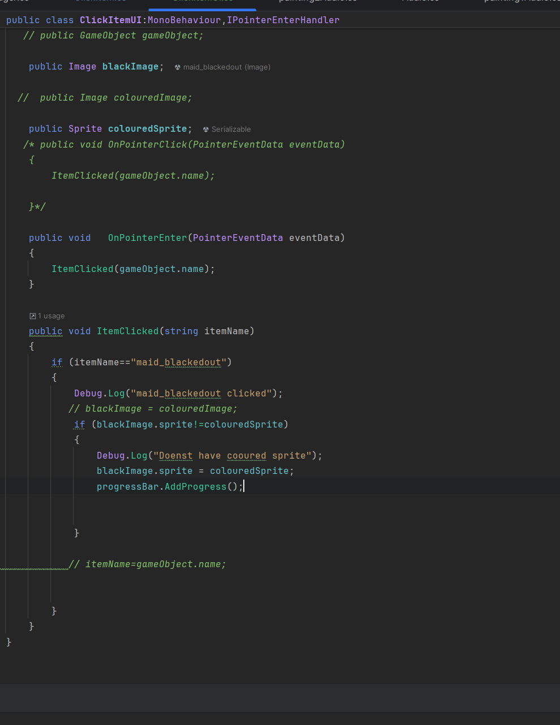

I use Image to access the image of the blackedOutMaid(will be passed into when the script is inside the blackout Maid gameobject). I want to change the sprite of the the blacked out maid image  into the sprite of the image of the coloured maid.Since it is UI I have to use the screenshot I showed above.

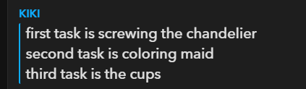

Wk 12 24/04 fixing bugs which I didn’t have time to do before the deadline

What I want to do

 Is to make sure the progressbar is increasing when progress.AddProgress() is used.

I will use debugs to clarify it does increase

Make invisible gameobjects for the paintings inside each scene and the gallery.

Change the inventory to use GameObjects not strings.

Make sure the GameObject sprites are added to inventory

Make sure anything related to clicking something works.

**making sure that when I click on the brunette lady, the cipher gets added to the inventory.**

**When a cipher gameobject  gets added to the inventory the painting is unlocked, which allows the player to be transported to the next scene.**

There were bugs after the game was put into itch.io,the producer gave us a list of teh bugs which occurred, and I aim to fix them.

The errors with the game objects not moving are gone after my teammate pushed her changes into github.

Problem 1

When I try to load into a scene, it says it's not a scene in build profiles, when it is a scene.

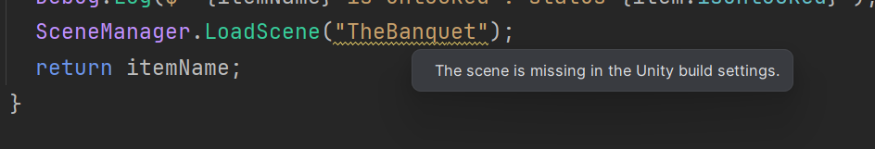

What I did to try and fix it:

Remove the scene list, so it only has the scenes that I want to use.I just decided to use the array of scenes I have and use levelManager.scene[6] to go to the banquet scene.

Problem2

My teammate told me that she already handled the thing, when the door inside mainroom is clicked it brings you to the gallery. My goal is to make the  brunette aristocrat clickable ,so once the progressbar is full in the banquet scene, and the player clicks on the the aristocrat, the cipher which is a gameobject is automatically added to the inventory.The inventory can be n=viewed once you press J.There will be a message indicating that it has been added. I will make the brunette aristocrat into a clickable Object, since when its unlocked(when the progress bar is full).

Problem2.1

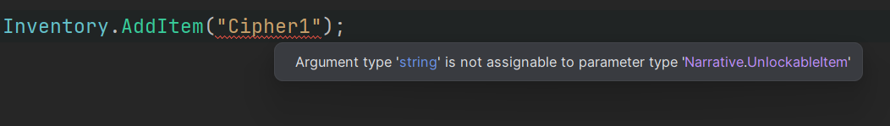

Before I wanted to add the items in unlockable items(list of items that will be unlockable) inside the inventory.But my teammate told me that the ciphers are gameObjects so I will need to change the inventory system to match the scriptableObjects;

I will change this

To store gameObjects instead of strings.We wil store the sprite of teh GameObject inside the inventory

The inventory will store gameObjects that contain the name Cipher. I will need to have and AddItem method that has a GameObject as a datatype which passes a name that can be accessed in other classes.If the GameObject name contains cipher then we add the gameobject sprite into the inventory.Ok in order to access the sprite I just use the put the inventory gameobject into the click Ui script, then ill put the sprite of the cipher into where the sprite reference is.

Problem 2.1.1

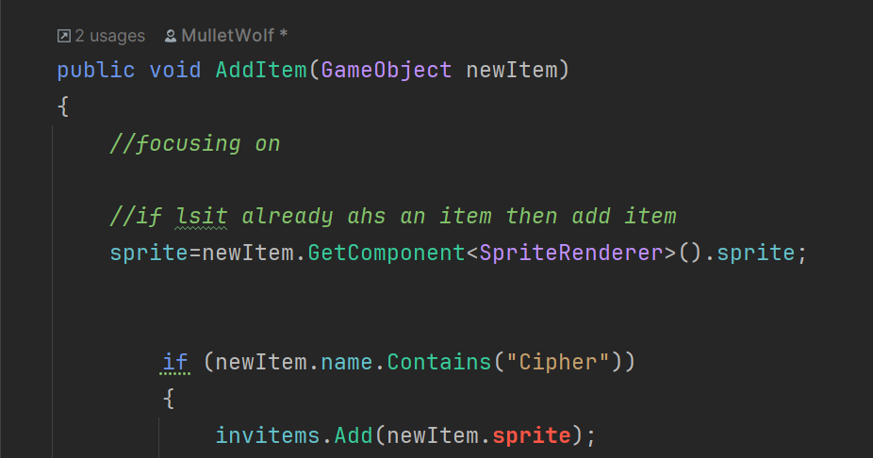

I noticed that i am getting errors when I try to get the sprite of the gameobject.I did some thinking an realized that if I am only storing the sprites inside the inventory, then I should use this.



I fixed it, the complete inventory that only stores the sprite of the gameObject.

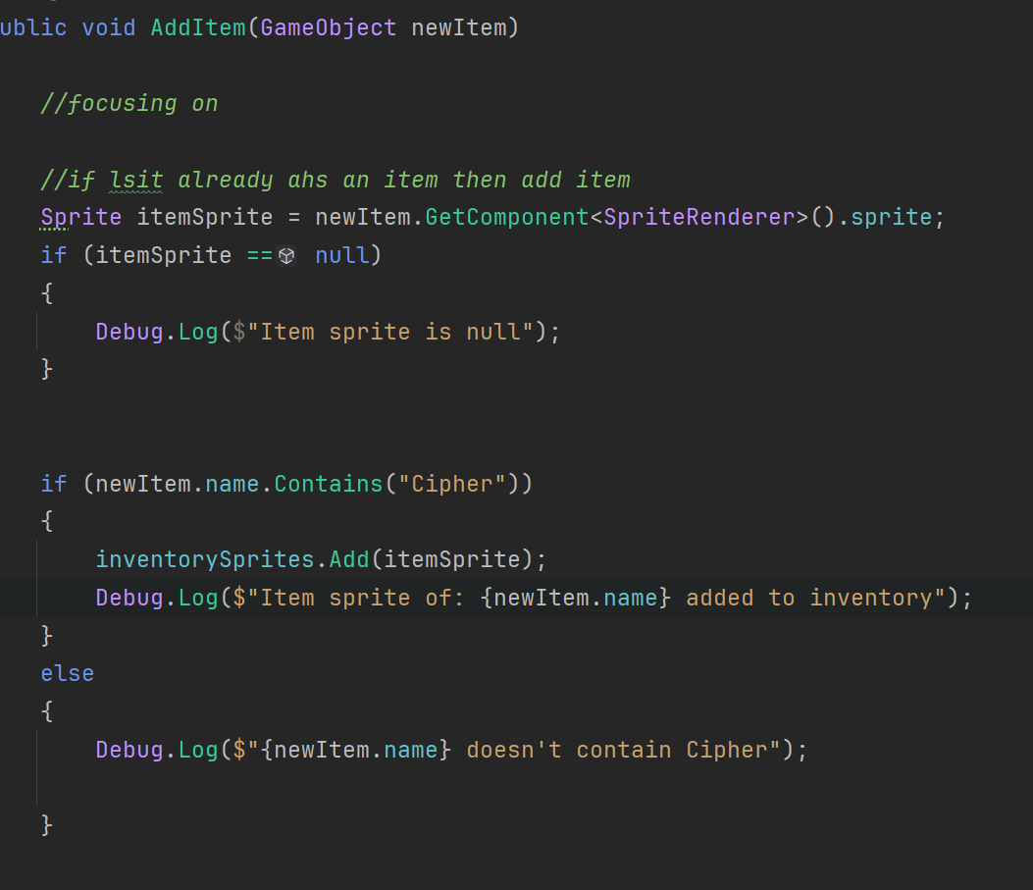

**Next is making sure that when I click on the brunette lady, the cipher gets added to the inventory.**

What I need to do

Create a cipher1 gameObject in the BanquetScene

Wait if I just have the clieckItemUI on teh brunette lady, it has teh inventory script which has the gameobject of the cipher ,so when I click on the lady the gameobject is added to the inventory.I will test that out.

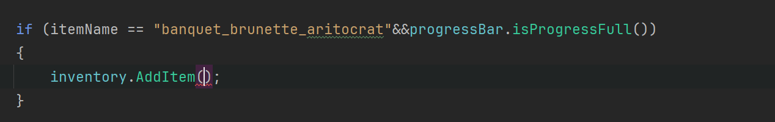

I'm trying to think of what to put here.I want it to pass the cipher gameObject into it, but how do I do that.Cant I reference a gameObject to the cipher i want to add .And only add it to the inventory if the name of the gameObject reference contains Cipher.

I like to have different clicks for different items, for different objects so it will be more readable.The cipherGameObject is the reference to the gameObject in the clickItem script which I will put the cipher game object in each clickItem script

This is what I came up with.

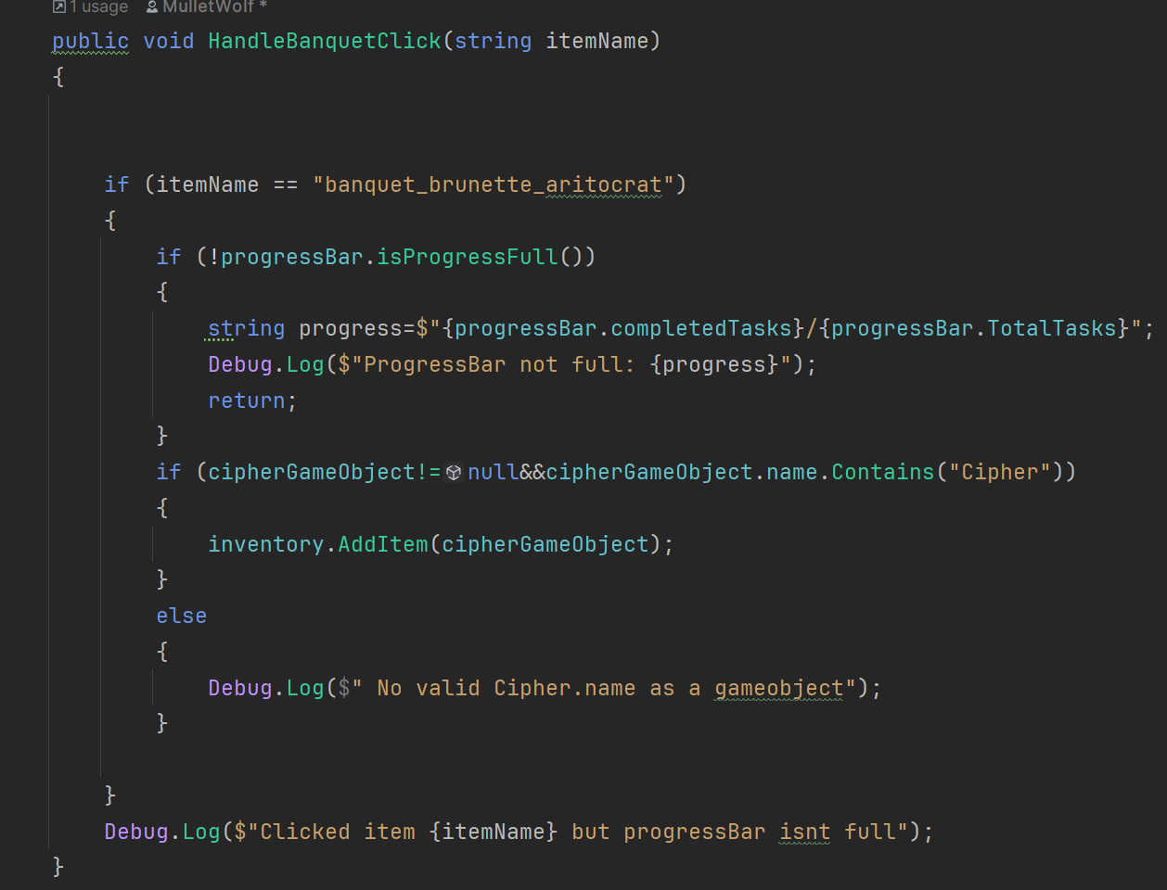

I will test it out to see if clicking on this specific ui image will work.I will create a gameObject called Cipher1 that has a sprite.then ill put this cipher1 gameObject into the gameobject of the reference in clickItemUi which is in the aristocrat.

The only way to make a gameObject invisible is to attach a script that makes the gamObject false.

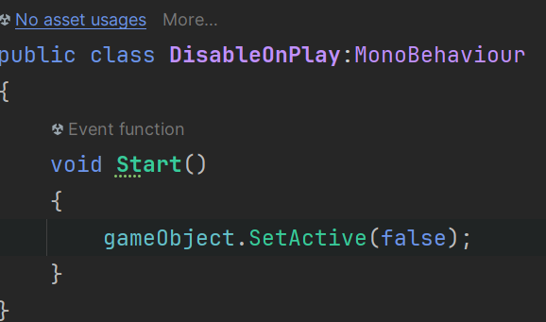

Problem 2.2

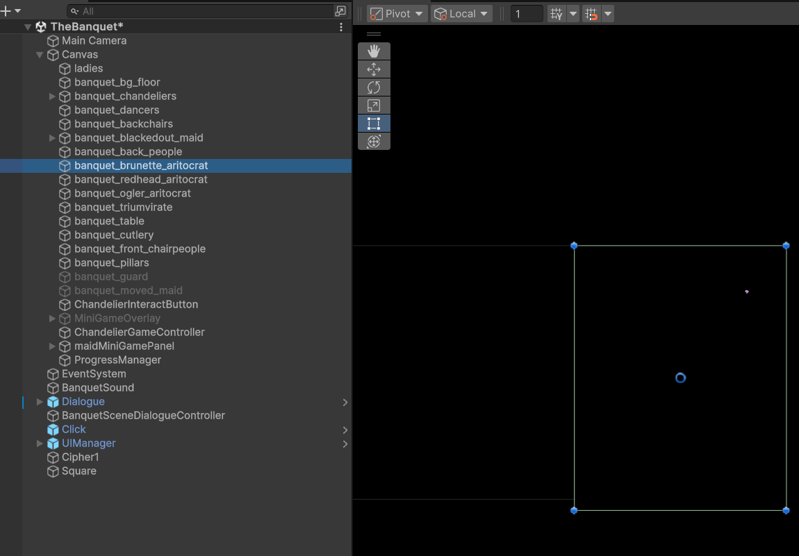

When I click on the aristocrat, I couldn’t see the actual image of it, I asked my teammate and she said that its supposed to do that, so I'm just going to create a gameObject and reference my inventory etc to it instead of to the aristocrat .Nevermind,i'll just put a square in the middle and the aristocrat around it,so I don't need to change anything.Green outline is the aristocrat.

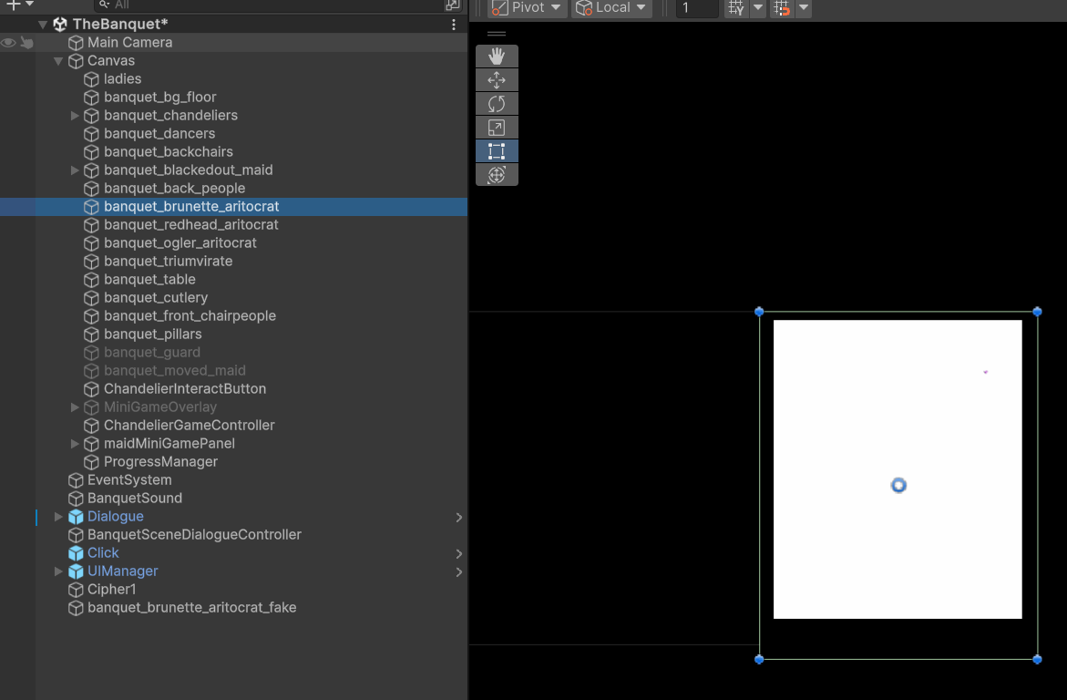

Problem

It’s not registering my clicks when I click on the aristocrat, which is confusing, since the aristocrat has the ClickItemUi script.I looked it up and it says that if a game object is in front of another game Object it blocks the clicks of the game object behind it .Instead of using a game Object i will just outline the image with red so I can f

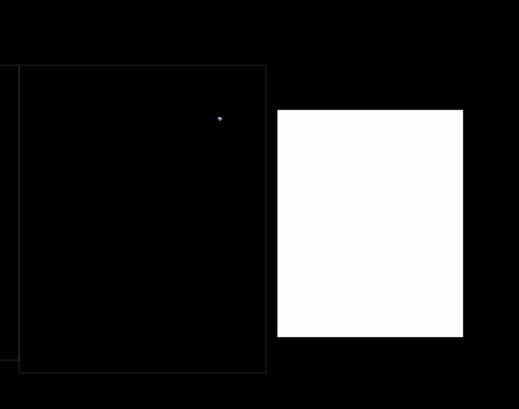

Not blocking, should work now. It didn’t. I think there is something blocking the UI image. I decided to use a UI rabbit as the fake UI image. It did work when I did that which means the problem is that something is blocking the aristocrat. Therefore, I will have to use recasting